**CHAPTER 1**

**INTRODUCTION**

**1.1 THE CELLULAR CONCEPT**

Mobile (radio) communication is understood as exchange of information between two or more users of which at least one user equipment is not located at a fixed position and may be moving around.

In cellular systems, radio communication takes place between a mobile station (MS) and a fixed station which is referred to as radio base station (RBS). Normally, in a cellular system, there is no direct communication between two mobile stations (there may be however extensions to cellular systems which allow also direct communication between MSs).

          The geographic area in which a mobile station is able to exchange radio signals with a radio base station is called a (radio) cell.

         A cellular system consists of set of (possibly overlapping) cells where each cell is served by one radio base station.

At one (antenna) site (“Standout”) several radio base stations may be co-located. By using sector antennas it is possible to establish several cells from a single site. The transmission direction from an MS to a RBS is denoted as uplink sometimes also referred toes reverse link.

The transmission direction from an RBS to an MS is denoted as downlink (sometimes also referred to as forward link).

**1.2 HISTORICAL DEVELOPMENT OF MOBILE COMMUNICATION SYSTEM**

**1.2.1 First-Generation Systems**

The first mobile cellular radio systems are based on analog transmission technology (at later stage employing digital signaling) and were designed for support of telephone speech service.

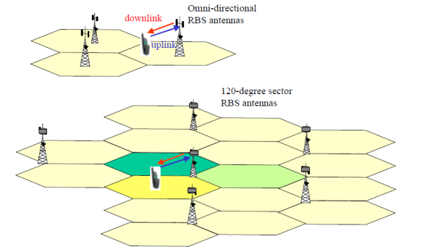

Figure 1.1 Cellular Radio Communication System

**1946** First mobile telephone service in the USA introduced by AT&T.

**1979** Pre-commercial operation of Advanced Mobile Phone System (AMPS) in US, MCS-L1 introduced in Japan by NTT (AMPS based, 25 kHz channels)

**1981** Commercial operation of NMT450 (Saudi Arabia and Sweden)

**1983** First commercial operation of AMPS (Chicago)

**1985** System C450 in commercial operation in Germany TACS system (AMPS based) in commercial operation in UK

**1.2.2 Second-Generation Systems**

         With the second-generation systems digital radio technology was introduced. Initially designed or circuit switched services such as telephone speech and low rate data. Further evolutions of second generation systems also support packet transmission with low-to-medium peak bit rate, e.g. General Packet Radio Service as supplement to GSM circuit switched services.

1982 GSM development started by “Group Special Mobile”

1988 ETSI formed in Europe MCS-L2 introduced in Japan (12.5 kHz channels)

1992 All major European operators start commercial operation of GSM networks

1993 First DSC1800 system in commercial operation in UK

1994 Commercial operation of D-AMPS (IS-54) in US started

1994 Commercial operation of PDC in Japan started by NTT

1995 Commercial operation of N-CDMA system (IS-95) in

Hong Kong/Korea

1995 PCS1900 (D-AMPS in 1900 MHz band, IS-136)

**1.2.3 Third-Generation Systems**

The future third-generation systems shall be distinguished from the second generation primarily in terms of the services offered to the users. Third-generation systems shall provide high-speed transmission rates and more efficient support of packet services. Spectrum-efficient high-speed data transmission has become feasible due to the advances in digital technology, both with respect to signal processing algorithms and integrated circuit technology.

Discussion of a potential successor system for GSM started in ETSI and other standard developing organizations already in the late 1980, even before any second-generation system was in commercial operation. The ETSI-term for the future system was Universal Mobile Telecommunications System (UMTS). Simultaneously, the International Telecommunication (ITU) also started discussions on a potential future mobile system initially referred to as Future Public Land Mobile System (FPLMTS) and started to specify a set of system requirements.

Due to the huge world-wide success of GSM, the interest among European network operators and manufacturers to consider a completely new system was rather low until to the mid 1990s. Only after the ITU has taken the initiative to formulate a concrete roadmap towards a new mobile system to be deployed in the early 2000s, the specification activities for UMTS in ETSI were ramped up in 1995.

Some pressure on ITU to speed-up 3G activities mainly came from Japanese operators and manufacturers, when it was predicted that the Japanese 2G-system PDC will soon reach its capacity limits. In contrast to the GSM community, in Japan there was only very little interest in a further evolution of PDC due to its small share of the international market.

The ITU term for the future 3G system was later changed to IMT-2000, International Telecommunications System for the 2000s. As part of the roadmap, a deadline for submission of proposals for IMT-2000 by the regional standardization development organizations was agreed to be in July 1998.

In Europe, research studies on candidate radio technologies for 3G systems started around 1989 with funding by the Commission of European Communities (CEC) in the RACE Mobile project line. From 1991 – 1995 two CEC funded research projects called Code Division Tested (CODIT) and Advanced Time Division Multiple Access (ATDMA) were carried out by the major European telecom manufacturers and network operators.

The CODIT and ATDMA projects investigated the suitability of wideband Code Division Multiple Access (CDMA) and Time Division Multiple Access (TDMA) based radio access technology for 3G systems. This work was later continued in the FRAMES (Future Radio Wideband Multiple Access System) project and became the basis of the further ETSI UMTS work until decisions were taken in 1998.

In January 1998 ETSI selected two radio transmission technologies (from originally 4 different proposals) for UMTS terrestrial radio access (UTRA), referred to as UTRA FDD and UTRA TDD, which were submitted to ITU as candidates for IMT-2000?

The terrestrial radio transmission technologies proposed to ITU in July 1998 are listed in Table 1.1. The proposals included a number of different Wideband CDMA (WCDMA) based radio access technologies, from ETSI, TTC/ARIB (Japan), TTA (Korea), ANSI T1 (USA) and TIA (USA), which can be grouped into two types. The one type of proposals requires synchronized base stations and is building up on the IS-95 2G radio transmission technology.

The other group of concepts does not rely on base station synchronization (there are however also cases where it is also needed). By the end of 1998 two specification development projects were founded by the regional standardization organizations, 3GPP (3rd Generation Partnership Project) and 3GPP2. The goal of both 3GPP and 3GPP2 was to merge a number of the W-CDMA based proposals into a single one, see Table 1.1. 3GPP2 was concerned with the IS-95 based systems.

The split of standardization activities into two camps was partly caused by a dispute on Intellectual Property Rights (IPR) on W-CDMA technology between various telecom manufacturers.

After these IPR issues were resolved in mid 1999, the members of 3GPP and 3GPP2 agreed on a harmonized global IMT-2000 CDMA proposal. The one type of proposals requires synchronized base stations and is building up on the IS-95 2G radio transmission technology.

This agreement then paved the way for a harmonized overall concept of a ITU IMT-2000 family of 3G systems as shown in Figure1. 2.

The IMT-2000 family of 3G systems includes

* Three types of Core Network technology:
* GSM based (using Mobile Application Part (MAP) protocols on top of SS7 protocols for signaling)
* ANSI-41 based (IS-634 protocols for signaling)
* Internet Protocol based (in future, to be specified)
* Five types of Radio Access Network technologies
* UTRA FDD (W-CDMA)
* UTRA TDD (W-CDMA combined with TDMA)

• Cdma2000-MC (N-CDMA with multiple carriers on downlink, W-CDMA uplink)

• UWC-136 (TDMA, TDD and FDD modes)

* DECT (TDMA, TDD); an extension to today’s DECT technology to enable the support of 3G services in wireless phones

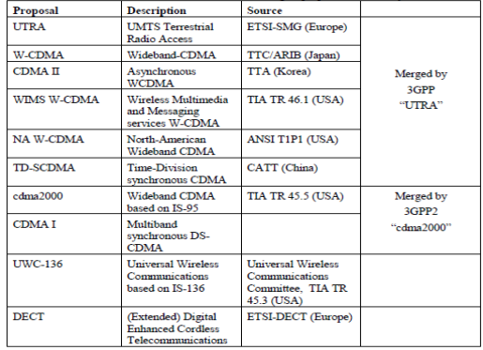

Table 1.1 Terrestrial Radio Transmission Technologies Proposed To ITU July 1998

**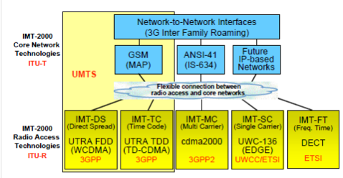**

Figure 1.2 ITU LMT- 2000 Family of 3g System

**1.3 OVERVIEWON IMT-2000 RADIO ACCESS TECHNOLOGIES**

The frequency bands allocated for initial operation of IMT-2000/UMTS systems is shown in Figure 1.3.

In Europe there is one paired frequency band in the range 1920 –1980 MHz and 2110 – 2170 MHz to be used for UTRA FDD and there are two unpaired bands from 1900 –1920 MHz and 2010 – 2025 MHz intended for operation of UTRA TDD.

In the USA 3G systems shall initially be operated in the PCS band which is already partly used for 2G systems. MSS refers to spectrum reserved for 3G mobile satellite systems (1980 - 2010 MHz and 2170 – 2200 MHz).

The PCS band in the USA was already divided into chunks of 5 MHz and mostly sold in form of 2×5 MHz paired band to PSC network operators before any 3G systems were proposed. This situation in the USA has imposed the requirement that it must be possible to operate a 3G system within a 2 × 5 MHz paired frequency band. Operation of the 3G system must even be possible when a different standard possibly working at a different power level is installed in the immediate neighboring bands without any additional guard band between these neighboring bands The UMTS band in Europe is therefore divided into twelve 5 MHz paired frequency slots, suitable for UTRA FDD, and four plus three 5 MHz unpaired frequency slots suitable for UTRA TDD mode.

In Germany the UMTS spectrum will be auctioned starting in July 2000. One operator is allowed to acquire at least two, at most three paired bands. Therefore there will be initially between 4 and 6 UMTS operators in Germany. Those operators who will receive a license for the paired band in the first round of the auction, are permitted to participate in a second round where the unpaired band will be auctioned.

In May 2000 further frequency bands for UMTS/IMT-2000 was identified by the ITU World Radio Conference (WRC-2000). These bands (more than 160 MHz additional spectrum) shall ensure future extension of UMTS. Today’s estimations expect worldwide 2 Billion mobile subscribers in the year 2010. At that time it is expected that 3G systems will carry about 66% of the mobile radio traffic.

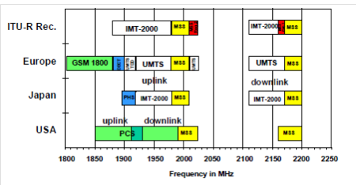

Figure 1.3 Spectrum Assigned To Operation of 3.5G System

These Figures shows the main characteristics of UTRA FDD, UTRA TDD, CDMA2000-MC and UWC-136. Details of these radio transmission technologies will be described in later sections.

The main time and spectral characteristics of the UTRA FDD mode are shown in Figure 1.4. The time signal structured into radio frames of 10 ms duration. A frame is divided into 15 time slots.

These time slots are only used to organize the data in form of a periodic structure. For instance the bits in the beginning of a slot may have a special meaning. In FDD mode each time slot can be used continuously by one user, i.e. the slots are not used for time division multiple access. The signals from different users are distinguished by using different spreading codes, i.e. the Code division Multiple Access (CDMA) method is employed (see Sec. 4.1). An important characteristic of the FDD mode is that each base station and each user can transmit its signals independent of the timing of transmissions of other base stations and users. No global base station synchronization required. A radio frame is divided into 38400 chip intervals. This results in a chip rate of 3.84 Mbps. In a frame 15×10×2*k* bits can be transmitted in every slot, where *k* is an integer. This signal fits into a 5 MHz band. Different bands are used to operate uplink and downlink. At a carrier spacing of 5 MHz it is possible to operate adjacent frequency channels at a different power level to establish different layers of cells with different size, e.g. micro-cell layer with low transmit power, and macro-cell layer at high power level. Macro-cells have a cell radius in the order of 2 – 20 km, micro-cells in the order of a few hundred meters to about 2 km, and even smaller cells are referred to as Pico-cells (normally used in indoor systems). Details of the UTRA FDD mode will be presented in other sections.

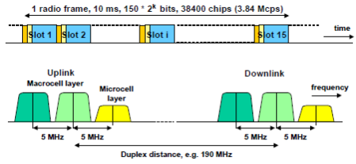

Figure 1.4 Main Characteristics of UTRA FDD

The main time and spectral characteristics of the UTRA TDD mode are shown in Figure 1.5. As in FDD, the time signal is structured into radio frames of 10 ms duration, and a frame is divided into 15 time slots. However in UTRA TDD each time slot can be allocated to a different user, i.e. there is time division multiple access (TDMA) applied (see Sec. 4.1). In addition, the slot structure is used to distinguish between transmission directions. Any slot in a frame can either be used in the uplink or in the downlink direction. Figure 1.5 shows one specific configuration example where only a single switching point between uplink and downlink direction is used. In every frame the same uplink/downlink switching is applied. A radio frame is as in FDD nominally divided into 38400 chip intervals. This results in the same chip rate of 3.84 Mbps as in FDD. However, due to the time division multiple access scheme, every user must ensure that his transmit signal arrives at the base station without overlapping into a slot allocated to another user and/or for the downlink direction, since this may create excessive interference. This means that the effective transmission time that can be utilized in each slot is by some guard space smaller than the nominal length of the time slot. In TDD a guard space of 96 chip intervals is used. Each user needs to control the timing of transmissions such that the signal burst arrives within his slot boundaries at the base station. Such a method that compensates the transmission delay is referred to as timing advance.

In the TDD mode in each time slot also code division multiple access (CDMA) is employed, i.e. TDD employs a hybrid TDMA/CDMA radio access technology. The maximum spreading factor is 16 chips per symbol and up to 16 different CDMA channels can then be established in each TDMA slot. For synchronization purposes each signal burst includes a special training chip sequence in the middle referred to as mixable. There are midambles of different lengths defined which can be used for adaptation to different transmission environments. The number of information bits that can be transmitted per burst depends on the length of the mixable and the employed spreading factor.

When TDD is employed in adjacent cells, the switching points between uplink and downlink transmissions need to be synchronized between different base stations. Otherwise too much interference would be created at cell boundaries to operate such a system reliably. This means that the clocks in base stations which control the slot structure must be synchronized with each other, i.e. base station synchronization is required in UTRA TDD based cellular systems.

The figure 1.6 illustrates the time and spectral characteristics of the cdma-2000-MC mode of IMT- 2000. This scheme is an extension of the narrowband CDMA system IS-95 standardized in the USA. The term “MC” refers to multi-carrier. It means that on the downlink three carriers of the IS-95 system can be combined to be used for data transmission to one mobile. In the uplink it is possible to perform direct spreading onto a chip rate of 3.6864 Mbps which is three times the chip rate of the IS-95 system (i.e. 3 × 1.2288 Mbps).

On the downlink the multi-carrier principle is employed because there are orthogonal codes employed. It would not be possible to employ direct spreading onto 3.6864 Mbps while maintaining orthogonality between the wideband and narrowband signals after modulation into the frequency band.

On the uplink, orthogonality is not intended anyway between different user signal(due to the involved high complexity). Therefore it is possible to mix narrowband carriers with wideband carriers in one band without compromising performance.

The time structure in cdma-2000-MC is on the downlink identical with the one used for IS-95. A radio frame is divided into time slots of 1.25 ms duration. From eight time slots a radio frame of 10 ms length can be built. It is however also possible to define 5 and 20 ms time intervals as frame length, with 4 and 16 slots, respectively. In the wideband mode on the uplink simply three times the chip rate is employed on the same frame and slot structure, enabling three times higher rate at the same spreading factor as in the narrowband mode.

The slot structure is not used for TDMA. However due to the spreading code generation Mechanism specified for this system all base stations require a common clock. Therefore CDMA- 2000-MC requires tight (chip-level) synchronization between all base stations. This is done by using the Global Positioning System (GPS) time as reference.

Figure 1.6 shows time format and spectral characteristics of UWC-136 which is also part of the IMT-2000 family of 3G standards. UWC-136 is an evolution of the IS-136 standard, the PCS band variant of the US TDMA (D-AMPS) standard. Note that IS-136 is a narrowband TDMA system that uses 30 kHz carriers and 3 TDMA slots per carrier. UWC-136 extends IS-136 with three new modes:

• TDMA/FDD mode with 200 kHz channel bandwidth which is equivalent with GSM EDGE(“Enhanced Data Rate for GSM Evolution”),

• TDMA/FDD mode with 1.6 MHz channel bandwidth (paired spectrum),

• TDMA/TDD mode with 1.6 MHz channel bandwidth (unpaired spectrum).

TDMA frames divided into 8 slots. Higher-level modulation schemes are used for support of higher bit rates, i.e. 16QAM as in GSM-EDGE. Furthermore one user may combine up to all eight slots for his own transmissions. The 1.6 MHz mode employs 64 slots per frame which yields with the same modulation schemes to 8 times the bandwidth of the 200 Hz mode.

This mode is primarily intended for indoor systems and to support very high rates up to 2 Mbps. There is also a TDD variant of the 64 slot/1.6 MHz scheme where the slots are divided between uplink and downlink transmission directions. In a given 5 MHz frequency band three 1.6 MHz channels could be established, enabling deployment of a system with frequency reuse 3.

**1.4 UMTS SPECIFICATION SERIES**

The 3GPP UMTS Technical Specifications (TS) and Technical Reports (TR) are numbered with a 2+3 digits number. The first two digits refer to a series number, which is separated from the other part by a dot. For instance, TS 21.101 is a 21-series UMTS specification. TS 21.101 provide the overall list of 3GPP specifications and explains the systematic of document numbering as partly recapped below.

Release 1999 Technical Specifications and Technical Reports were functionally frozen in

December 1999. Corrective changes however will be introduced into the Release 1999 version 3.x.y specifications throughout the year 2000.

**21-Series: Requirements Specifications**

These specifications are often transient and contain requirements leading to other specifications. They may become obsolete when technical solutions have been fully specified; they could then, e.g., be replaced by reports describing the performance of the system, they could be deleted without replacement or be kept for historical reasons but turned into background material. When found necessary and appropriate, the transient or permanent nature of a requirement specification may be expressed in its scope.

**22-Series: Service Aspects**

Specifications in this series specify services, service features, building blocks or platforms for services (a service feature or service building block may provide certain generic functionality for the composition of a service, including the control by the user; a platform may comprise a single or more network elements, e.g. UIM, mobile terminal, auxiliary system to the core network etc.);

Stage1 specifications that are felt appropriate belong to this series; reports defining services which can be realized by generic building blocks etc. also belong to this series.. When found necessary and appropriate, the transient or permanent nature of a requirement specification may be expressed in its scope.

**23-Series: Technical Realization**

This series mainly contains stage 2 specifications (or specifications of a similar nature describing interworking over several interfaces, the behavior in unexceptional cases, etc.).

**24-Series: Signaling Protocols (UE - CN Network)**

This series contains the detailed and bit-exact stage 3 specifications of protocols between MS/UE and the Core Network.

**25-Series:** UTRA aspects

**25.100-Series:** UTRA radio performance aspects

**25.200-Series:** UTRA radio aspects**,** (physical) layer 1

**25.300-Series:** UTRA radio interface architecture, layer 2 and layer 3 (RRC) aspects

**25.400-Series:** UTRA network aspects, transport interfaces in UTRAN (Iub,Iur & Iu)

**26-Series: Codes (Speech, Video, Etc.)**

This series defines speech codec and other codec (video etc.).

**27-Series: Data**

This series defines the functions necessary to support data applications.

**28-Series:** Reserved for future use.

**29-Series: Signaling Protocols (NSS)**

This series contains the detailed and bit-exact stage 3 specifications of protocols within the Core Network.

**30-Series: Programmed Management**

This series contains the 3GPP 3rd Generation Mobile System, project plans/ project work program and stand-alone documents for major work items.

**31-Series: UIM**

This series specifies the User Identity Module (UIM) and the interfaces between UIM and other entities.

**32-Series: Operation and Maintenance**

This series defines the application of TMN for the 3GPP 3rd Generation Mobile System and other functions for operation, administration and maintenance of a 3rd Generation Mobile System network.

**33-Series: Security Aspects**

This series contains specifications of security functions.

**34-Series: Test Specifications**

This series contains test specifications. The transient or permanent nature of a requirement specification may be expressed in its scope.

**CHAPTER 2**

**GSM RADIO NETWORK PLANNING**

## 2.1 OVERVIEW

The design of radio network planning (RNP) is the basis of the construction of a wireless mobile network. The design level of network planning decides the future layout of a network.

During network planning, the documents concerning base station distribution, channel assignment, and cell data must be outputted. And the major tasks involved are as follows:

1. Analyze carriers’ requirements on network coverage, capacity and quality.
2. Analyze the coverage and capacity features of the candidate mobile communication systems and bands, and then analyze the investment feasibility through estimating the network scale.
3. Decide the network structure and base station type based on further analysis.

* First analyze whether to construct a layering network according to user distribution, propagation conditions, city development plan and existed network conditions, and then analyze the sites within this area to decide whether to use omni antennas or directional antennas to meet the requirements on coverage and capacity.

1. Estimate the number of base stations

* Before estimating the number of base stations, estimate the coverage distance of base stations of various types in various coverage areas. The factors deciding the effective coverage area of a base station include:
* Valid transmit power of the base station
* Working bands to be used (900 MHz or 1800 MHz)
* Antenna type and installation position
* Power budget
* Radio propagation environment
* Carriers’ indexes on coverage

1. Plan an ideal base station address according to cellular structures.

* According to geographic maps or administrative maps and with the help of on-the-spot surveys, you can have a full understanding of the areas to be planed, and then mark the area where the number of users is large as a target address. After that, mark the addresses of other base stations according to the ideal cellular structure and the result of link budget.

1. Calculate the number of channels of the cells of each base station

* Estimate the traffic of a base station according to its ideal location, and then obtain the number of carriers and channels needed by each base station by checking Erl table according to the indexes of call loss rate.
* Decide the frequency reuse mode according to band width, network quality requirement, and equipment supportability.
* Estimate the maximum base station configuration type according to the frequency bandwidth and reuse mode provided by the construction carriers. If the system capacity in some areas cannot be met, you need to add more base stations or cells to the system according to cell splitting principles and actual conditions. After that, reselect an ideal base station address on the map and re-estimate the number of channels required by the base station.

1. Predict the coverage area and decide the project data, namely, perform the preliminary emulation. The specific tasks are as follows:

* Select the design indexes:

Select the minimum received power and the penetration ratio index at the coverage area edge.

* Select the design parameters, which includes:

Antenna height (above the ground), antenna azimuth angle, antenna gain, antenna tilt angle, base station height above sea level, base station type, feeder length, antenna feeder system loss, combining and distribution modes, transmitter output power, receiver sensitivity, base station diversity reception, and diversity gains.

* Predict the coverage area of each cell according to the propagation models in different areas, and then give the opinions on adjusting the base station address, antenna direction, antenna tilt angle, and antenna height in the areas where dead zones may be present and signals are poor. Finally, provide the project data.

1. Select actual base station address and decide base station type:

* Perform filed examination according to the ideal base station addresses, and then record the possible addresses according to various construction conditions (including power supply, transmission, electromagnetic background, and land taken over). Finally, recommend a suitable address based on integrated consideration of the deviation from the ideal base station address, the effect on future cell splitting, economic benefits, and coverage prediction.
* After the base station address is selected, decide the actual base station type according to the number of base station channels.
* After the base station type is decided, you need to make a scheme for antenna configuration. For moving a network, if you intend to provide a best combination scheme for the antenna feeders, you must fully investigate the combination of the antenna feeders of the original carriers, plan the future expansion of the base station, and design the combination of the antenna feeders supported by current equipments.

1. Plan frequency and adjacent cell

* Decide the frequency and adjacent planning according to the actual base station distribution and type.

1. Make cell data

* To ensure that the network runs stably, you must design the parameters relative to performance for each cell. These parameters include system information parameters, handover parameters, power control algorithm parameters, and so on.

## 2.2 PLANNING FOUNDATION

### 2.2.1 Coverage And Capacity Target Confirmation

Before planning a network, you must confirm the network coverage and capacity target and relative specifications from carriers. They are specified as follows:

* Definition of coverage areas
* Specific division of the service quality in coverage areas
* Grade of service (GOS) at Um interface.
* Prediction of network capacity and subscriber growth rate
* Available bands and restrictions on using bands
* Restrictions on base station address and the number of carriers
* Penetration loss in cars or indoor environment
* Performance and sensitivity of base stations
* Rules on base station naming and numbering
* Information of the base stations in the existing network

Engineers perform the network planning and guide the subsequent construction work according to the previous technical specifications. Because any change of these specifications will affect network construction, you must discuss these specifications with carriers and get their confirmation.

### 2.2.2 Performance Target Confirmation

Carriers emphasize much on the future network quality. Therefore, network planning engineers must judge the indexes concerning network performance according to construction difficulty and experience, and then cooperate with carriers to design a reasonable solution.

Generally, the performance of voice services can be judged according to KPI indexes, which are specified in 0

|  |  |  |  |  |
| --- | --- | --- | --- | --- |
| Number | KPI index | Meaning | Test method | Reference value |
| 1 | TCH congestion ratio | TCH seizure failures/attempted TCH seizures × 100% | OMC | < 2% |
| 2 | SDCCH congestion ratio | SDCCH seizures and all busy times/SDCCH seizure requests × 100% | OMC | < 1% |
| 3 | Call drop ratio | TCH call drop times/TCH occupation success times × 100% | OMC | < 2% |
| 4 | Handover success ratio | Handover success times/handover attempted times × 100% | OMC | > 92% |
| 5 | Call setup time | Average call setup times | Drive test | < 10s |
| 6 | Coverage probability | The percentage of the received level greater than -90 dBm | Drive test | > 90% |
| 7 | FTP average download rate (kbps) | Applied to GPRS | Drive test | ≥ 16 |
| 8 | FTP average upload rate (kbps) | Applied to GPRS | Drive test | ≥ 3.2 |
| 9 | Forward/reverse transmission delay | Applied to GPRS | Drive test | < 20s |
| 10 | Ping success ratio | Applied to GPRS | Drive test | ≥ 90% |
| 11 | Ping average delay | Applied to GPRS | Drive test | < 3.5s |
| 12 | Mean opinion score (MOS) | The voice quality is divided into fiver levels from excellent to bad. | Drive test | ≥ 3 |
| Note:  The KPI indexes vary slightly with carriers. | | | | |

Table 2-1 Descriptions of KPI indexes

The mean opinion score (MOS) in the previous table is divided into five levels, which are specified in 0.

|  |  |
| --- | --- |
| Quality level | Quality evaluation standard |
| 5 | Excellent |
| 4 | Good |
| 3 | Fair |
| 2 | Poor |
| 1 | Bad |
| Note:   * The call whose quality is above level 3 can access the mobile communication network. * The call whose quality is above level 4 can access the public network. | |

Table 2.2 Mean opinion score (MOS)

## 2.3 COVERAGE ANALYSIS

### 2.3.1 Area Division

#### I.Types of coverage area

The signal propagation models are applied in accordance with the propagation environments in areas of different types. The signal propagation models decide the design principles, network structures, grade of services and frequency reuse modes for the radio networks in coverage areas.

In order to decide the cell coverage area, you can the radio coverage areas into the following four types:

* Big city
* Middle-sized city
* Small town
* Countryside

|  |  |
| --- | --- |
| Area type | Description |
| Big city | * Dense population * Developed economy * Large traffic * Dense high buildings and mansions distributed in center areas * Flourishing shopping centers |
| Middle-sized city | * Relatively dense population * Relatively developed economy * Relatively large traffic * Dense buildings distributed in center areas * Active and promising shopping centers |
| Small town | * Relative large population * Promising economic development * Moderate traffic * Relative dense buildings distributed in center areas * A certain scale of shopping centers but with great potentiality |
| Countryside | * Scattered population * Developing economy * Low traffic |

Table 2.3 Coverage area division

In addition, you must consider the coverage of the areas at the intersections and various transport arteries, including:

* Express way
* National high way
* Provincial highway
* Railway
* Sea-route
* Roads in mountain areas

Generally, it is recommended to apply omni base stations in the countries plains and the areas with restricted landforms.

In big cities, middle-sized cities, and along expressways, it is recommended to apply directional base stations.

#### II. Define The Field Strength At Coverage Area Edges

When defining the field strength of the uplink edges of a service area, you must consider the factors listed in Error! Reference source not found..

|  |  |
| --- | --- |
| Factor | Value |
| Mobile station sensitivity | -102 dBm |
| Fast fading protection | 4 dB (3 dB for countryside) |
| Slow fading protection | 8 dB (6 dB for countryside) |
| Noise (environmental noise and interfering noise) protection | 5 Db |

Table 2.4 Typical factors concerning the definition for the filed strength at coverage area edges

**III. Define Coverage Probability**

The definition of coverage probability varies with the coverage areas, and the coverage probability is gradually improved along with the construction of the network.

In China, the coverage probability can be defined according to 0.

|  |  |  |
| --- | --- | --- |
| Construction stage | Areas | Coverage target |
| Early stage | Significant national tourism areas, expressways, national highways, and the areas along busy railways. | Full coverage. |
| Other major roads, railways and sea-routes | The coverage probability must be greater than 90%. |

Table 2-5 Definition of coverage probability at different stages and in different areas

**2.3.2 Radio Environment Survey**

Through surveying radio propagation environments, you can get familiar with the overall landforms, estimate the rough antenna height, and select the proper radio propagation model, among which the radio propagation model helps you estimate the number of base station when predicting the coverage. If necessary, you must adjust the propagation model.

For GSM 900MHz, the formulas estimating radio path loss in different areas are simplified.

|  |  |  |  |
| --- | --- | --- | --- |
| Formula | Application area | Propagation model adopted | Example |
| PLDU = 147.2 + 8d + 40.5lgd | Densely populated urban areas | Walfish-Ikegami | If carrier frequency = 925 MHz, hBTS<hobstacle, and d < 0.5km, hBTS = 25mhobstacle = 30m, street width = 25m, building width = 50m |
| PLU = 128.73 + 38lgd | Common urban areas | Walfish-Ikegami | If carrier frequency = 925MHz and hBTS>hobstacle, hBTS = 25m, hobstacle = 20m, street width = 25m, building width = 50m |
| PLSU = 126 + 35lgd | Suburban areas | Okumura-Hata | If carrier frequency = 925MHz, hBTS = 30m |
| PLRU = 116 + 35lgd | Countryside areas | Okumura-Hata | If carrier frequency = 925MHz, hBTS = 30m |

Table 2.6 Formulas estimating radio path loss in different areas

## 2.4 TRAFFIC ANALYSIS

## 2.4.1 Traffic Prediction And Cell Splitting

#### I. Traffic Prediction

The network construction requires the consideration of economic feasibility and rationality. Therefore, a reasonable investment decision must be based on the prediction of the network capacity of the early and late stage.

When predicting network capacity, you must consider the following factors:

* Population distribution
* Family income
* Subscription ratio of fixed telephone
* Development of national economy
* City construction
* Consumption policy

After predicting the total network capacity, you must predict the density of subscriber distribution. Generally, base stations are constructed in urban areas, suburban areas, and transport arteries. Therefore, you can use the percentage of prediction method.

At the early stage of construction, the subscribers in cities account for a larger percentage of the total predicted subscribers. With the development of the network construction, the percentage of the subscribers in suburban areas and transport arteries grows.

The traffic of each subscriber is 0.025 Erl in urban areas and 0.020 Erl in suburban areas. In this way, the number of voice channels needed for a base station can be obtained through predicting the traffic.

In a GSM system, you can use Erl model to calculate the traffic density that the network can bear. The call loss can be 2% or 5% depending on actual conditions.

Because restrictions on cell coverage area and the width of the available frequencies are present, you must plan the cell capacity reasonably. If good voice quality is ensured, you must enhance the channel utilization ratio as much as possible.

In actual networking, if the network quality is ensured at a certain level, two capacity solutions are available, namely, a few stations with high-level configuration and multiple stations with low-level configuration. Both the advantages and disadvantages of the two solutions are apparent, so which one should be used depending on the actual conditions of an area.

For network construction, you can expand the capacity either through adding base stations or through expanding the base station capacity. The expansion strategies adopted must be in accordance with the traffic density in an area.

For example, the strategies such as adding 1800 MHz base stations, expanding sector capacity, adding micro cells, or improving indoor coverage can be used to expand network capacity.

#### II. Cell Splitting

Cell splitting is quite effective for the expansion of network capacity. An omni base station can split into multiple sectors, and a sector can split into multiple smaller cells. In other word, you must plan cell radius in accordance with the traffic density of an area.

Cell splitting means more base station and greater cost are needed. Therefore, when planning a network, you must consider the following factors:

* The rules and diagrams of frequency reuse are repeatable.
* The original base stations can still work.
* The transition cells must be reduced or avoided.
* The cell can split without effect.

Cell splitting is quite important in a network. The followings further describe the cell splitting based on 1-to-4 splitting.

Cell splitting is used to split a congested cell into multiple smaller cells. Through setting the new cells whose radiuses are smaller than the original cells and placing them among the original cells, you can increase the number of channels in a unit area, thus increasing channel reuse times. In this case, system capacity is expanded.

Through adjusting the project parameters relative to antenna feeders and reducing transmitter power, you can narrow the coverage area of a cell. shows that a cell splits into four smaller cells by half of its radius.

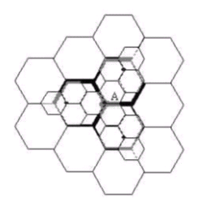

Figure 2.1 Schematic diagram of cell splitting (1-to-4)

As shown in 0, smaller cells are added without changing the frequency reuse mode. They are split proportional to the shape of the original cell clusters.

In this case, the coverage of a service area depends on the smaller cells, which are 4 times outnumber of the original cells. To be more specifically, you can take a circle with the radius R as an example, the coverage area of the circle with the radius R is 4 times that of a circle with the radius R/2.

According to 0, after cell splitting, the number of cell clusters in the coverage area increases. Thus the number of channels in this coverage area increases and the system capacity is expanded accordingly.

You can adjust the coverage area of the new cells through reducing the transmit power. For the transmit power of the new cells whose radiuses are half of that of the original cell, you can check the power “Pr” received at the new cell edge and at the original cell edge, and make them equal.

However, you must ensure that the frequency reuse scheme of the new micro cells is the same as that of the original cell. As for 0,

* Pr [at the edge of the original cell] = Pt1R-n, and,
* Pr [at the edge of the new cell] = Pt2 (R/2)-n

Here, Pt1 and Pt2 are the transmit power of the base stations of the original cell and the new cell, and n is path fading exponent. If make n = 4, make the received power at the edge of the new and original cell equal, the following equation can be obtained:

Pt2 = Pt1/16

That is to say, if the micro cells are used to cover the original coverage area and the requirement of S/I is met, the transmit power must be reduced by 12 dB.

Not all cells need splitting. In fact, it is quite demanding for carriers to find out a perfect cell splitting scheme. Therefore, many cells of different scales exist in a network simultaneously. As a result, the minimum distance among intra-frequency cells must be maintained, which further complicate frequency allocation. In addition, you must pay attention to the handover because success handover ensure the all subscribers to enjoy good quality of service regardless of moving speed.

As shown in 0, when two layers of cells are present within an area but their coverage scale is different, according to the formula Pt2 = Pt1/16, neither all new cells can simply apply the original transmit power, nor all original cells can simply apply the new transmit power.

If all cells apply great transmit power, the channels used by smaller cells cannot be separated from the intra-frequency cells. If all cells apply lower transmit power, however, some big cells will be exclusive from the service areas.

For the previous reason, the channels in the original cells can be divided into two groups. One group meets the reuse requirement of the smaller cells, and the other group meets the reuse requirement of the bigger cells. The bigger cells are applied to the communication of fast-moving subscribers, which requires a fewer handover times.

The power of the two channel groups decides the progress of cell splitting. At the early stage of cell splitting, the channels in the low-power group are fewer.

As the requirement grows, more channels are needed in low-power group. The cell splitting does not stop until all channels within this area are applied in the low-power group. In this case, all cells in this area have split into multiple smaller cells, and the radius of each cell is quite small.

### 2.4.2 Voice Channel Allocation

#### I.Voice channel decision

The base station capacity refers to the number of channels that must be configured for a base station or a cell. The calculation of the base station capacity is divided into the calculation of the number of radio voice channels and the calculation of the number of radio control channels.

According to the information of base stations and cells and the density distribution of subscribers, you can calculate the total number of the subscribers. Then according to the radio channel call loss ratio and traffic, you can obtain the number of voice channels that must be configured by checking Erl B table.

Generally, you can decide the number of voice channels as follows:

1. According to the bandwidth and the reuse mode allowed by current GSM networks within the areas to be planned, you can obtain the maximum number of carriers that can be configured for a base station.
2. Each carrier has 8 channels. You can obtain the maximum number of voice channel numbers that can be configured for a base station by detracting the control channels from the 8 channels.
3. According to the number of voice channels and call loss ratio (generally 2% dense traffic areas and 5% for other areas), you can obtain the maximum traffic (Erl number) that the base station can bear through checking Erl B table.
4. Through dividing the Erl number by the average busy-hour traffic of subscribers, you can obtain the maximum number of subscribers that the base station can accommodate.
5. According to the data of subscriber density, you can obtain the coverage area of the base station.
6. After the areas are specified based on the subscriber density, according to the area of an area and the actual coverage area of the base station, you can calculate the number of needed base stations.
7. For important areas, you must consider back up stations and the cooperation between carriers. For example, an important county needs at least two base stations and three important carriers.
8. For the areas where burst traffic is possible, such as the play ground and seasonal tourism spots, you must prepare the equipments (such as carriers and micro cells) and frequency resources for future use.
9. The dynamic factors, such as roaming ratio, subscriber mobility, service development, industry competition, charging rate change, one-way charge, and economic growth, must be considered.
10. To configure a base station, you must consider the transmission at the Abis interface so that the capacity can be met while saving transmission. For example, the application and concatenation of the Abis interface 15:1 and 12:1 should be considered.
11. For indoor coverage and capacity, you can use micro cells and distributed antenna systems. For the coverage in countryside areas and highroads, you can use economical micro base stations. For the transmission in countryside areas and highroads, you can use HDSL because it is cost effective.
12. In some special areas, you can use the base stations consisting of omni and directional cells, but you must consider the isolation between omni antennas and directional antennas. For traffic control, you can use the algorithm in terms of network layers.
13. For some highroads which require a little traffic by large coverage, you can use the two networking modes. They are:

* (A micro base station with single carrier) + (0.5 + 0.5 cell with two set of directional antennas)
* A micro base station with single carrier + 8-shaped antenna

#### II. Relationship between carrier number and bearable traffic

Erl traffic model can calculate the traffic that a network can bear. The call loss ratio can be 2% or 5% according to actual conditions. 0 describes the relationship between the number of carriers and the traffic that a network can bear according to Erl B table.

|  |  |  |  |
| --- | --- | --- | --- |
| Number of carriers in each cell | Number of TCHs | Traffic (Erl) | |
| – | – | 2% | 5% |
| 1 | 6 | 2.27 | 2.96 |
| 2 | 14 | 8.2 | 9.73 |
| 3 | 21 | 14.03 | 16.18 |
| 4 | 29 | 21.03 | 23.82 |
| 5 | 36 | 27.33 | 30.65 |
| 6 | 44 | 34.68 | 38.55 |
| 7 | 52 | 42.1 | 46.53 |
| 8 | 59 | 48.7 | 53.55 |
| 9 | 67 | 56.25 | 61.63 |
| 10 | 75 | 63.9 | 69.73 |

Table 2.7 Relationship between the number of carriers and the traffic that a network can bear

According to this table, the larger the number of carriers and the call loss ratio are, the greater the traffic that each TCH bear, and the greater the TCH utilization ratio is (the channel utilization ratio is an important indicator of the quality of network planning and design). If the number of subscribers of a base station is small, you can consider delaying the construction.

Because restrictions on the coverage area of a cell and the bandwidth of the available frequencies, you must plan a reasonable capacity for the cell.

If good voice quality is ensured, you must take measures to enhance the channel utilization ratio as much as possible.

In actual applications, when the traffic on each TCH accounts for 80-90% of total given by Erl B table (the call loss ratio is 2%), the congestion ratio in this cell rise greatly.

Therefore, we generally calculate the traffic that a network can bear by taking the 85% of the traffic given by Erl B table as a reference.

#### Example

The capacity of a local network needs to be expanded. According to the service development, population growth and mobile popularity, the subscribers in this area are expected to reach 100,000 in 2 years.

If only the followings are considered:

* Roaming factor (according to the development trend of traffic statistics) = 10%.
* Mobile factor (the subscriber moves slightly within the local network instead of roaming) = 10%.
* Dynamic factor (with burst traffic considered) = 15%.

The network capacity = 100000 \* (1 + 10% + 10% + 15%) = 135,000.

However, because the congestion is present, we generally calculate the traffic that a network can bear by taking the 85% of the traffic given by Erl B table as a reference. As a result, the network capacity must be designed as follows:

The network capacity = 135, 000/85% = 158,800, about 160,000.

### 2.4.3 Control Channel Allocation

#### I. SDCCH allocation

Stand-alone dedicated channel (SDCCH) is an important channel in a GSM network. Mobile station activities, such as location update, attach and detach, call setup and short message, are performed on SDCCH. The SDCCH is used to transmit signaling and data.

It describes SDCCH configuration. It is difficult to induce a traffic model for the SDCCH; especially it even becomes impossible after the large-scale application of layering networks and short messages.

Moreover, the equipments of some carriers support SDCCH dynamic allocation function. As a result, the traffic model for SDCCH must be adjusted according to actual conditions.

The advantages of the SDCCH dynamic function are as follows:

* Adjusting SDCCH capacity dynamically
* Reducing SDCCH congestion ratio
* Reducing the effect of initial SDCCH configuration against system performance
* Making SDCCH and TCH configuration more adaptive to the characteristics of cell traffic
* Optimizing the performance of the systems under the same carrier configuration.

In conclusion, the SDCCH dynamic allocation function is divided into two types, namely,

* Dynamic allocation from SDCCH to TCH
* Dynamic recovery from SDCCH to TCH

#### II. CCCH allocation

Common control channels (CCCH) contain access grant channel (AGCH), paging channel (PCH) and random access channel (RACH). The function of a CCCH is sending access grant message (immediate assignment message) and paging message.

All traffic channels in each cell share the CCCH. The CCC can share a physical channel (a timeslot) with SDCCH, or it can solely occupy a physical channel. The parameters relative to the CCCH include CCCH Configure, BS AG BLKS PES, and BS PA MFRMS.

CCCH Configure designates the type of CCCH configuration, namely, whether the CCCH shares one physical channel with the SDCCH. If there are 1 or 2 TRX in a cell, it is recommended that the CCCH occupies a physical channel and share it with the SDCCH. If there are 3 or 4 TRXs, it is recommended that the CCCH solely occupies a physical channel. If there are more than 4 TRX, it is recommended to calculate the capacity of the paging channels in the CCCH according to actual conditions first, and then you can perform the configuration.

BS AG BLKS PES indicates that the number of CCCH message blocks reserved to the AGCH. After CCCH configuration is done, this parameter, in fact, decides allocates the ratio of AGCH and PCH in CCCH. Some carriers can set sending priority for the “access grant message and “paging message”. When the former message set to be prior to the later one, the BS AG BLKS PES can be set to 0.

BS PA MFRMS indicates the number of multi-frames that can be taken as a cycle of paging sub-channels. In fact, this parameter decides the number of paging sub-channels that a cell can be divided into.

## 2.5 Base Station Number Decision

After traffic and coverage analysis, according to the selected base station equipments and parameters, you can obtain the coverage areas of various base stations through link budget.

The coverage area helps you calculate the number of base stations required by each area. Then you decide the base station configuration according to traffic distribution. Finally, you must perform emulation using relative planning software so that coverage, capacity, carrier-to-interference ratio can be assured and interference can be avoided.

### 2.5.1 Characteristics of 3-sector base stations in urban areas

Cellular communication is named because the coverage areas of base stations are extruded through small cellular-shaped blocks. In urban areas, for the purpose of capacity expansion and radio frequency optimization, mainly 3-sector base stations are used. This section explains some basic concepts of a 3-sector base station.

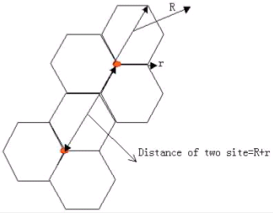

Figure 2.2 -sector cellular layout

This is a standard 3-sector cellular layout. According to 0, the distance between two 3-sector base stations is R + r, here R = 2r. However, “R” is mainly used in cell radius estimation because the direction along “R” is the direction of the major lobe of the directional antenna. In the design for cellular layout, however, “r” indicates the cell radius.

In a cellular cell, if the included angle between a direction and the direction of the major lobe of the antenna, the coverage distance along this direction is r = R/2, and the path loss along this direction is about 10dB less than that along the direction of the major lobe of the antenna (for the deduction.

It is introduced in the following), namely, the equivalent isotropic radiated power (EIRP) along this direction can be about 10dB less than that along the major lobe.

According to this feature, in the cellular layout of this kind, you can adopt the directional antenna whose azimuth beam width ranges from 60 to 65 degrees because their horizontal lobe gain diagram also meets this feature.

If “R” is the cell radius, the cell area is S = 0.6495 × R × R. Sometimes the “r” is used as cell radius, so the cell area is S = 2 5981×r×r. Therefore, when calculating the cell area, you must make clear whether “r” or “R” is used.

It shows the relationship between “R” and “r”.

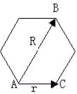

Figure 2.3 Relationship between “R” and “r”

The followings deduce the EIRP required along “R” direction and “r” direction.

As shown in 0, the coverage distance along “r” direction is half of that along “R” direction, namely, r = R/2. To keep even coverage, you must make the field intensity at the edges of the cell equal, namely, Rx level B = Rx level C.

Suppose that the EIPR transmitted from cell A is EIRPR  and EIRPr along “R” direction and “r” direction respectively, and the city HATA mode is used for path loss, the path loss from point A and B is expressed as equation (1) :

* EIRPR – RXLEVB = 69.55 + 21.66lgf - 13.82lgh1 + (44.9 - 6.55lgh1) lgR (1)

And the path loss from pint A to point C is expressed as equation (2):

* EIRPr- RXLEVc = 69.55 + 21.66lgf - 13.82lgh1 = (44.9 - 6.55lgh1) lgr (2)

Subtract (2) from (1), the equation (3) is expressed as follows:

* EIRPR - EIRPr=(44.9 - 6.55lgh1)×(lgR – lgr) =(44.9 - 6.55lgh1) × lg (R/r) (3)

Introduce R = 2r, the equation (4) is obtained as follows:

* EIRPR - EIRPr = 0.3 × (44.9 - 6.55lgh1) (4)

0 shows the relationship between antenna height and values of (EIRPR - EIRPr).

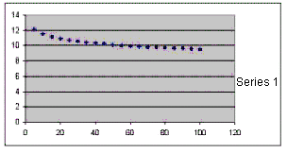

Figure 2.4 Relationship between antenna height and values of (EIRPR - EIRPr)

As shown in 0, when the antenna height “h1” increases from 5m to 100m, the values of (EIRPR - EIRPr) decrease from 12 to 9.5, which can be roughly treated as 10dB.

### 2.5.2Uplink and Downlink Balance

After base station parameters are specified, you can perform link budget to estimate the coverage area of the base station. In addition, you must consider the sensitivity of the base station equipments at this time.

In a mobile communication system, radio links are divided into two directions, namely, uplink and downlink. For an excellent system, you must perform a good power budget so that the balance is present between uplink signals and downlink signals. Otherwise, the conversation quality is good for one party but bad for the other party at the edges of the cell. If uplink signals are too bad, the mobile station cannot start a call even if signals are present.However, the because the fading for uplink channels and downlink channels is not totally the same and the other factors such as the difference of the performances of receivers are present, the calculated uplink and downlink are not absolute, but the there a fluctuation of 2 to 3 dB.

The measurement report on uplinks and downlinks at the Abis interface can tell whether the uplink and downlink reach a balance. In addition, dialing tests in actual network can also tell whether the balance between uplinks and downlinks are reached.

If the conversation quality on downlinks uplinks becomes poor simultaneously, it means that the downlinks and uplinks are balance.

When calculating uplink and downlink balance, you must consider the functions of the tower amplifier first. In a base station receiving system, the thermal movement of the active parts and radio frequency (RF) conductors cause thermal noise, which reduces the signal-to-noise ratio of the receiving system.

In this case, the receiving sensitivity of the base station is restricted and the conversation quality is reduced. To improve the receiving performance of the base station, you can add a low-noise amplifier under the receiving antenna. And this is the principle of the tower amplifier.

The contributions of the tower amplifier to uplinks and downlinks are judged according to the performance of its low-noise amplifier and gain. In fact, it is the tower amplifier that reduces the noise coefficient of the base station receiving system. The power amplifier can improve the coefficients for the uplink receiving system (start from the output end of the receiving antenna).

However, if the functions of the tower amplifier are quantified by this, the uplink improved value can be represented by the NFDelta(it is the reduced value of the noise coefficient of the receiving system) after a tower amplifier is added to the system.

1. **No Tower Amplifier**

When there is no tower amplifier, the sensitivity of the equipments at the duplexer input Interface at the top of the base station cabinet are taken as a reference.

For downlink signals, if,

* Mobile station receiver output power = Poutm
* Base station diversity received gain = Gdb
* Base station receiving level = Pinb
* Base station side noise deterioration = Pbn
* Antenna receiving gain = antenna transmitting gain (according to reciprocity theorem)

#### Bass Station Sensitivity

This section further introduces the base station sensitivity and the functions of the tower amplifier.

Receiver sensitivity refers to the minimum signal level needed to by the input end of the receiver when the certain bit error rate (BER) is met. The receiver sensitivity detects the performances of the following components:

* Receiver analog RF circuit
* Intermediate frequency circuit and demodulation
* Decoder circuit

Three parameters are used to measure the receiver bit error performance. They are frame expurgation rate (FER), residual bit error rate (RBER), and bit error rate (BER). When a fault is detected in a frame, this frame is defined as deleted one.

Here,

* FER indicates the ratio of the deleted frames to the total received frames. For full rate voice channels, the FER is present when the 3-bit cyclic redundancy check (CRC) detects errors or bad error indication (BFI) is caused. For signaling channels, the FER is present when the fire code (FIRE) or other packet codes detect errors. The FER is not defined in data services.
* FBER indicates the BER that are not announced as deleted frames, namely, it is the ratio of the bit errors in the frame detected as “good” to the total number of bits transmitted in “good” frames.
* BER indicates the ratio of the received error bits to all transmitted bits.

Because BER occurs at random, the statistical measurement is mainly applied to measure receiver error rate. That is, sample multiple measuring points on each channel and when the number of measuring points is certain, if the BER of each measurement is within the required limit, the BER of this channel meets the BER as required.

**CHAPTER 3**

**UMTS ARCHITECTURE**

**3.1 NETWORK ARCHITECTURE**

**3.1.1 Review Of The GSM Network Architecture**

A GSM network (infrastructure domain) as shown in Figure 10, is divided into two domains, the Core Network (CN) domain and the Radio Access Network (RAN) domain.

The CN is further divided into two domains, the Circuit Switched (CS) Core Network domain and the Packet Switched (PS) Core Network Domain. This has mainly historical reasons, since GSM was initially designed for support of CS domain services.

Support of PS domain services was added in a later phase of GSM development (GSM phase 2+). It is denoted as General Packet Radio Service (GPRS) and currently being included by the network operators into their GSM systems.

**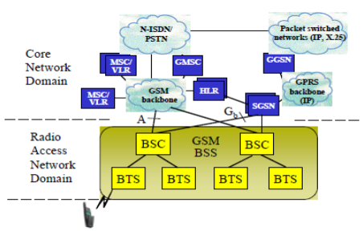**

Figure 3.1 Today’s GSM System Architecture

The GMSC then fetches the user-specific location information from a register (called Home Location Register, HLR) and routes the call to an MSC that can provide the service to the mobile user through a Radio Access Network.

The CS domain GSM Core Network consists of a number of network nodes referred to as Mobile Services Switching Centers (MSCs) which are inter-connected by circuit switched transmission lines, referred to as GSM backbone.

Today using Synchronous Transfer Mode (STM) technology for data transmission.

A GSM backbone can be an independent network of transmission lines and Transit Switches, or it can be based completely or partly on leased lines of the public narrowband ISDN (N-ISDN) network.

There are two types of mobile services switches, ordinary MSCs and Gateway MSCs (GMSCs).

A GMSC is distinguished from an (ordinary) MSC by providing some additional functions needed to setup calls between GSM and external networks. For instance when a call is set up from an external network to GSM, the call is first routed to a GMSC without knowledge of the whereabouts of the mobile user.

A HLR includes a record of all subscriber information relevant to the provision of telecommunication services.

Typically a HLR is a standalone computer without switching capabilities, able to manage the data of hundreds of thousands of users/subscribers.

A second data base function, called Visitors Location Register (VLR), contains the data of users within the serving area of an MSC, including the present location of the user on a more precise level than it is stored in the HLR.

The PS domain GSM Core Network consists of Serving GPRS Support Nodes (SGSNs) and Gateway GPRS Support Nodes (GGSNs).

SGSNs and GGSNs are connected through an Internet Protocol (IP) based backbone network.

GGSNs provide the connectivity with external packet switched Networks, e.g. Internet and X.25-protocol based packet data networks.

Signaling System No. 7 (SS7) protocols are used for exchange of control information between MSCs/GMSCs and HLR.

The GSM Radio Access Network consists of several Base Station Subsystems (BSS). A BSS consists of a Base Station Controller (BSC).

which is connected to one specific MSC through an open (standardized) interface referred to as A-Interface, and

a number of Base Transceiver Stations (BTSs, sometimes in short also referred to as Base Stations, BS, or Radio Base Stations, RBS).

A BTS is the node that provides radio service for a single specified (radio) cell. If GPRS is supported, a BSC is also connected to a SGSN through the GB-Interface.

**3.1.2 Umts Network Architecture**

The strategy of introduction of UMTS services is to integrate UMTS Terrestrial Radio Access Networks (UTRAN) into existing GSM systems as illustrated in Figure 11. Initially UMTS services will likely be established in certain hot-spot areas like cities, airports, etc. UTRAN will be connected to the GSM core network domain through an open interface, denoted as Iu interface.

Services which are already supported by GSM can be provided by existing MSCs or GSNs, while newly introduced UMTS services will require upgraded Core Network Nodes (3G-MSCs, 3G-GSNs). The UMTS IU interface employs Adaptive Transfer Mode (ATM) technology for data transport which enables efficient data transport of both circuit switched and packet switched services (see Sec. 2.4), whereas in today’s GSM networks Synchronous Transfer Mode (STM) is applied. STM refers to classical circuit switched based transport networks as used today in ISDN.

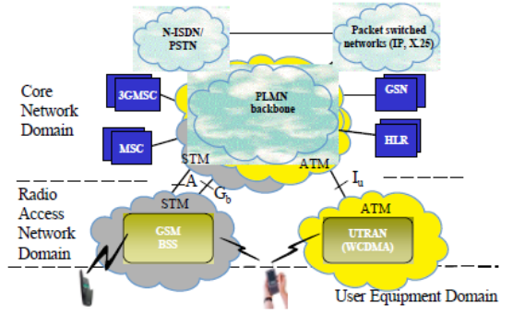

Figure 3.2 UMTS Architecture (1st Step of Migration with GSM)

The architecture of an UTRAN is shown in Figure 12. It consists of one or several Radio Network Systems (RNS) which corresponds to a BSS in GSM radio access networks. An RNS is comprised of a Radio Network Controller (RNC) which controls several Node B.

The term Node B refers to a site where several radio base stations are co-located, with each such radio base station serving one cell. A Node Bs is connected to an RNC via the Iub Interface. There is also an interface between RNCs, referred to as Iur Interface. Such an interface does not exist in GSM access networks. In GSM, there is only a small amount of communication between different RNS entities needed which is handled through the Core Network but which requires radio access network dependent functions in the Core Network domain. As illustrated in Figure 12 a User Equipment (UE) can simultaneously be served by multiple cells, i.e. it can be connected with multiple Node Bs. If a UE is connected to Node Bs of different RNS, the Iur interface is needed to exchange the data with the Serving RNC (S-RNC) which at a given time provides the connection with the Core Network via the Iu interface. As the Iu interface, ATM technology is employed also on the Iur and Iub interfaces (see Sec. 2.4).

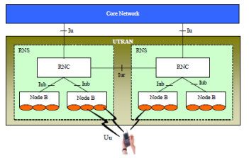

Figure 3.3 UTRAN Architecture

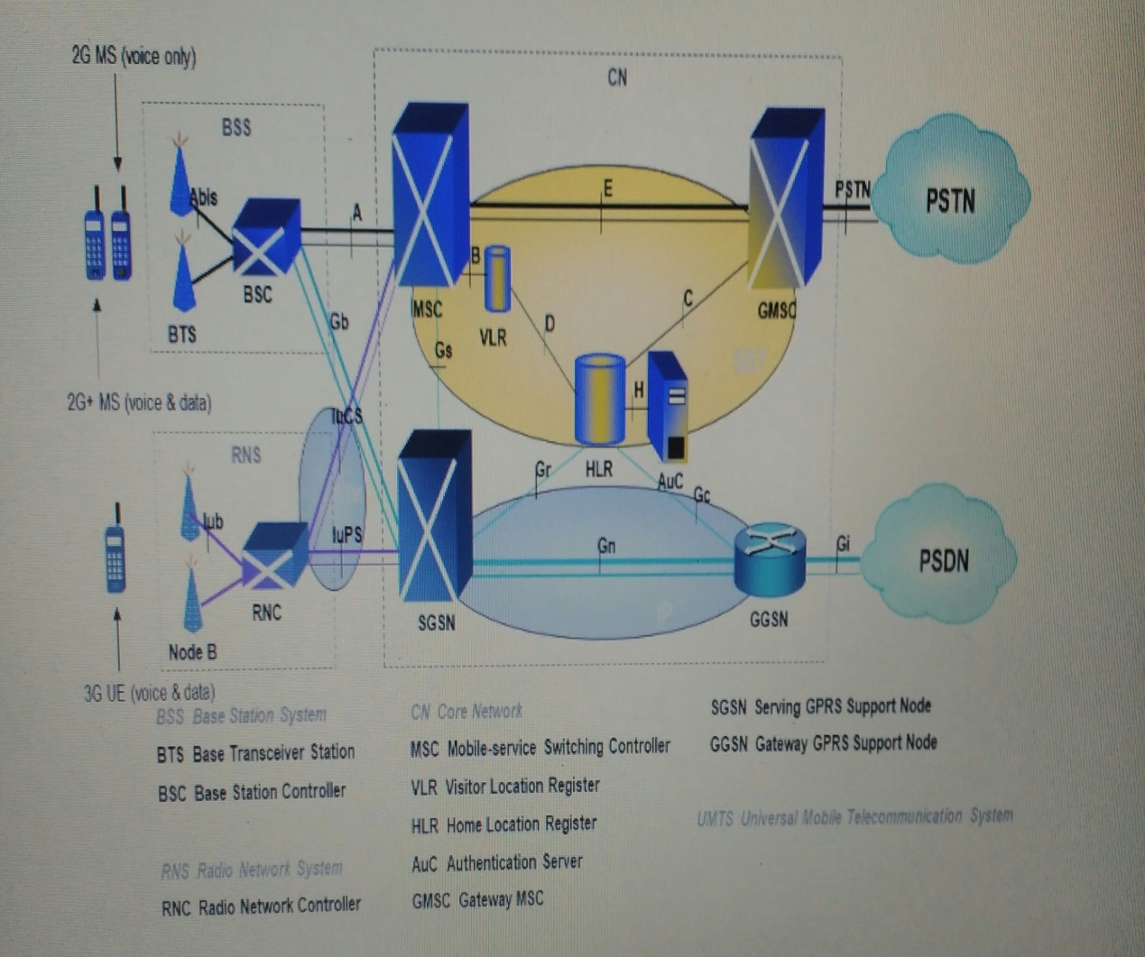

Figure 3.4 3GRel Architecture (UMTS)-3G Radio

**CHAPTER 4**

**WCDMA CHANNEL STRUCTURE**

**4.1 WCDMA UPLINK AND DOWNLINK CHANNELS**

A channel represents the logical connection between the UE and the Radio Access Network. They are physically represented by a Channelization code used between the RBS and UE. They are controlled, however, by the RNC along with the rest of the radio resources. We have three different types of channels, with each type being mapped into the next as shown in Figure

**logical**

Eg. DCCH, DTCH, BCCH BCCH

**TRANSPORT**

eg. BCH , PCH, FACH, RACH

Figure 4.1 WCDMA Channel Types

**4.2 Logical Channels**

Logical channel types refer to the type of information being transmitted, and are classified into two groups:

Control channels for the transfer of control information.

Traffic channels for the transfer of user information.

A brief description of the logical channels found in the uplink and downlink now follows:

* The Broadcast Control Channel (BCCH) is a downlink channel for broadcasting system information.
* Paging Control Channel (PCCH) is a downlink channel that transfer spacing inforaionan disused when the UE is in idle mode.
* The Common Control Channel (CCCH)

It is a bi-directional channel that transfers control information between the network and UE. This channel is used by the UE needs to access the network.

* The Dedicated Control Channel(DCCH) is a point-to-point Bi-directional channel that transmits dedicated control information between UE and the network. This channel is established through a RRC connection setup procedure.
* The Dedicated Traffic Channel(DTCH)

It is a point-to-point channel, dedicated to one UE, for transferring user information.

**4.3 TRANSPORT CHANNELS**

A transport channel is defined by how, and with what a characteristic, data is transferred over the air interface. There are two types of transport channels:

1 Common channels.

2 Dedicated channels.

Common channels are broadcast to everyone in the cell, whereas dedicated channels are transmitted and received from one user only. A brief description of some of the transport channels now follows:

There is one dedicated transport channel.

* Channel (DCH), which  is used in both downlink and uplink. The DCH is set-up for a voice call of data session, and characterized by the possibility of fast rate change and fast power control.
* The Broadcast channel (BCH) is a downlink transport channel that is used to

 broadcast system and cell specific information, in System information blocks.

* The BCH is always transmitted over the entire cell (to both active and idle UEs) with a low fixed bit rate
* The Forward Access Channel
* (FACH) is a downlink transport channel that carries control information to UEs when a random access message has been sent by the UE to the base station. It’s counterpart, the Random Access channel(RACH) is used in the uplink to send in the random access message from the UE.
* The Paging Channel(PCH)  is a downlink transport channel used for paging.

The High Speed Downlink Shared Channel(HS-DSCH):

It is a common transport  channel shared by all the HSDPA users in the cell. It is mapped onto up to 15 physical channels, depending on the number of codes available for Transport channels are further mapped onto physical channels, which are defined by channelization codes, and the Radio Frequency at which they are broadcast.

**4.4 PHYSICAL CHANNELS**

Transport channels are further mapped onto physical channels, which are defined by channelization codes, and the Radio Frequency at which they are broadcast.

**Common Downlink Physical Channels:**

In this section we take a brief look at the function of the common downlink physical channels, which are transmitted to all UEs.

* The Primary Common Control Physical Channel(P- CCPCH): Broadcasts system information. The Broadcast channel is the transport channel that maps onto this physical channel.
* Synchronization Channel (SCH)  carries the primary and secondary Synchronization Codes, which are used for slot synchronization, frame synchronization and the detection of the scrambling code group(oneoutof64). It is time multiplexed (only first 10%) with the P-CCPCH (remaining 90% of timeslot).
* Secondary Common Control Physical Channel(S-CCPCH): This channel is mapped to by both the Paging Channel(PCH) and the Forward Access Channel(FACH). Transmits idle mode signaling and control information to UE Can also be used for sending short infrequent data.
* CommonPilot Channel(CPICH):Sends   the scrambling code of the cell. Provides coherent phase reference for DL channels and aids channel estimation (handoverandcellselection). It is used in open loop power control to gauge the initial transmit

**Common Uplink Physical Channels:**

* Physical Random Access Channel (PRACH):This channel is used to carry access requests; control information and short data bursts. It uses only Open-loop power control and contains therefore  no pilot or TPC bits. The Broadcast channel is the transport channel that maps onto this physical channel. Common channels are broadcast to everyone in the cell, whereas dedicated channels are transmitted and received from one user only

**CHAPTER 5**

**WCDMA RADIO NETWORK PLANNING**

**5.1 INTRODUCTION**

This chapter presents WCDMA radio network planning, including dimensioning, detailed capacity and coverage planning, and network optimization. The WCDMA radio network planning process is shown in Figure 8.1. In the dimensioning phase an approximate number of base station sites, base stations and their configurations and other network elements is estimated, based on the operator’s requirements and the radio propagation in the area.

The dimensioning must fulfill the operator’s requirements for coverage, capacity and quality of service. Capacity and coverage are closely related in WCDMA networks, and therefore both must be considered simultaneously in the dimensioning of such networks

In Section 8.3, detailed capacity and coverage planning is presented, together with a WCDMA planning tool. In detailed planning, real propagation maps and operator’s traffic estimates in each area are needed. The base station locations and network parameters are selected by the planning tool and/or the planner. Capacity and coverage can be analyzed for each cell after the detailed planning.

One case study of the detailed planning is presented in Section with capacity and coverage analysis. When the network is in operation, its performance can be observed by measurements, and the results of those measurements can be used to visualize and optimize network performance. The planning and the optimization process can also be automated with intelligent tools and network elements. The optimization is introduced in Section 5.3.

As most WCDMA-based networks will be deployed on top of the GSM network, the GSM Co-planning issues need to be considered.

The adjacent channel interference must be considered in designing any wideband systems where large guard bands are not possible. The effect of interference between operators is analyzed and network planning solutions are presented. Presents the WCDMA frequency variants and their differences. These frequency variants are needed in the first place to deploy WCDMA in the USA.

****

Figure 5.1 WCDMA radio network planning process

**5.2 DIMENSIONING**

WCDMA radio network dimensioning is a process through which possible configurations and the amount of network equipment are estimated, based on the operator’s requirements related to the following.

Coverage:

* coverage regions;
* area type information;
* Propagation conditions.

Capacity:

* spectrum available;
* subscriber growth forecast;
* Traffic density information.

Quality of Service:

* area location probability (coverage probability);
* blocking probability
* End user throughput.

Dimensioning activities include radio link budget and coverage analysis, capacity estimation and, finally, estimations on the amount of sites and base station hardware, radio network controllers (RNC), equipment at different interfaces, and core network elements (i.e. Circuit Switched Domain and Packet Switched Domain Core Networks).

**5.2.1 Radio Link Budgets**

The link budget of the WCDMA uplink is presented in this section. There are some WCDMA-specific parameters in the link budget that are not used in a TDMA-based radio access system such as GSM. The most important ones are as follows.

* Interference margin: The interference margin is needed in the link budget because the loading of the cell, the load factor, affects the coverage: see Section 8.2.2. The more loading is allowed in the system, the larger is the interference margin needed in the uplink, and the smaller is the coverage area. For coverage-limited cases a smaller interference margin is suggested, while in capacity-limited cases a larger interference margin should be used. In the coverage-limited cases, the cell size is limited by the maximum allowed path loss in the link budget, and the maximum air interface capacity of the base station site is not used. Typical values for the interference margin in the coverage-limited cases are 1.0–3.0 dB, corresponding to 20–50% loading.
* Fast fading margin (¼ power control headroom): Some headroom is needed in the mobile station transmission power for maintaining adequate closed loop fast power control. This applies especially to slow-moving pedestrian mobiles where fast power control is able to effectively compensate the fast fading. The power control headroom was studied in. Typical values for the fast fading margin are 2.0–5.0 dB for slow-moving mobiles.
* Soft handover gain: Handovers – soft or hard – give a gain against slow fading (¼ lognormal fading) by reducing the required log-normal fading margin. This is because the slow fading is partly uncorrelated between the base stations, and by making a handover the mobile can select a better base station. Soft handover gives an additional macro diversity gain against fast fading by reducing the required Eb=N0 relative to a single radio link, due to the effect of macro diversity combining. The total soft handover gain is assumed to be between 2.0 and 3.0 dB in the examples below, including the gain against slow and fast fading. The handovers are discussed in Section 9.3 and the macro diversity gain for the coverage in Section 12.2.

Other parameters in the link budget are discussed in Chapter 7 in [2]. Below, three examples of link budgets are given for typical UMTS services: 12.2 kbps voice service using AMR speech codec, 144 kbps real-time data and 384 kbps non-real-time data, in an urban macro-cellular environment at the planned uplink noise rise of 3 dB. An interference margin of 3 dB is reserved for the uplink noise rise. The assumptions that have been used in the link budgets for the receivers and transmitters are shown in Tables 5.1 and 5.2.

****

**Table 5.1**. Assumptions for the mobile station

****

**Table 5.2**. Assumptions for the base station

The link budget in Table 5.3 is calculated for 12.2 kbps speech for in-car users, including 8.0 dB in-car loss. No fast fading margin is reserved in this case, since at 120 km/h the fast power control is unable to compensate for the fading. The required Eb=N0 is assumed to be 5.0 dB. The Eb=N0 requirement depends on the bit rate, service, multipath profile, mobile speed, receiver algorithms and base station antenna structure. For low mobile speeds, the Eb=N0 requirement is low but, on the other hand, a fast fading margin is required. Typically, the low mobile speeds are the limiting factor in the coverage dimensioning because of the required fast fading margin. Table 8.4 shows the link budget for a 144 kbps real-time data service when an indoor location probability of 80% is provided by the outdoor base stations.

The main differences between Tables 5.3 and 5.4 are the different processing gain, a higher mobile transmission power and a lower Eb=N0 requirement. Additionally, headroom of In this 4.0 dB is reserved for the fast power control to be able to compensate for the fading at 3 km/h. An average building penetration loss of 15 dB is assumed here.

The value on row q gives the maximum path loss between the mobile and the base station antennas. The additional margins on rows r and t are needed to guarantee indoor coverage in the presence of shadowing. The shadowing is caused by buildings, hills etc. and is modeled as log-normal fading. The value on row u is used in the calculation of the cell range.

.

From the link budgets above, the cell range R can be readily calculated for a known propagation model, for example the Okumura–Hata model or the Wolfish–Ikegami model.

For more on propagation models see e.g. [3]. The propagation model describes the average signal propagation in that environment, and it converts the maximum allowed propagation loss in dB on the row u to the maximum cell range in kilometers. As an example we can take the Okumura–Hata propagation model for an urban macro cell with base station antenna height of 30 m, mobile antenna height of 1.5 m and carrier frequency of 1950 MHz [4].

According to Equation (8.2), the cell range of 12.2 kbps speech service with 141.9 dB path loss in Table 8.3 in a suburban area would be 2.3 km. The range of 144 kbps indoors would be 1.4 km. Once the cell range R is determined, the site area, which is also a function of the base station sectorisation configuration, can then be derived. For a cell of hexagonal shape covered by a unidirectional antenna, the coverage area can be approximated as 2.6R2.

The process of evaluating the cell range is summarized in Figure 5.2. 5.2.2 Load Factors the second phase of dimensioning is estimating the amount of supported traffic per base station site. When the frequency reuse of a WCDMA system is 1, the system is typically interference-limited and the amount of interference and delivered cell capacity must thus be estimated.



Figure 5.2. Cell range calculation

**Power Splitting Between Frequencies**

In Figure 5.6 a base station maximum power of 20 W is assumed. What would happen to the downlink performance if the maximum power was lowered to 10 W? The difference in downlink coverage and capacity between 10W and 20W base station output powers is shown in Figure 5.9. If we lower the downlink power by 3.0 dB, the maximum allowed path loss is 3 dB lower. The effect on the capacity is smaller than the effect on the coverage because of the load curve. If we now keep the downlink path loss fixed at 156 dB, which is the maximum uplink path loss with 3 dB interference margin, the downlink capacity is decreased by only 5% (0.2 dB) from 760 kbps to 720 kbps. Increasing downlink transmission power is an inefficient approach to increasing the interference limited downlink capacity, since the available power does not affect the pole capacity.

Assume we had 20W downlink transmission power available. Splitting the downlink power between two frequencies would increase downlink capacity from 760 kbps to 2720 kbps ¼ 1440 kbps, i.e. by 90 %. The splitting of the downlink power between two carriers is an efficient approach to increasing the downlink capacity without any extra investment in power amplifiers. The power splitting approach requires that the operator’s frequency allocation allows the use of two carriers in the base station.



Figure 5.3 Effect of base station output power to downlink capacity and coverage

The advantages of the wideband technology in WCDMA can be seen in the example above. It is possible to make a trade-off between the downlink capacity and coverage: if there are fewer users, more power can be allocated for one user allowing a higher path loss. The wideband power amplifier also allows the addition of a second carrier without adding a power amplifier. On the other hand, WCDMA requires very linear base station power amplifiers, which is challenging for the implementation.

**5.2.2 Capacity Upgrade Paths**

When the amount of traffic increases, the downlink capacity can be upgraded in a number of different ways. The most typical upgrade options are:

* more power amplifiers if initially the power amplifier is split between sectors;
* two or more carriers if the operator’s frequency allocation permits;
* Transmit diversity with a 2nd power amplifier per sector.

The availability of these capacity upgrade solutions depends on the base station manufacturer. All these capacity upgrade options may not be available in all base station types. Chapters 6 and 7 in [3] provide an extensive overview of coverage and capacity enhancement methods.

An example capacity upgrade path is shown in Figure 8.11. The initial solution with one power amplifier and one carrier gives 680 kbps capacity while the two-carrier three-sector transmit diversity solution gives 2\_3\_760\_1.2 ¼ 5.5 Mbps assuming 20% capacity increase from the transmit diversity.

**Table 5.4**An example capacity upgrade path for 3-sector macro site

These capacity upgrade solutions do not require any changes to the antenna configurations, only upgrades within the base station cabinet are needed on the site. The uplink coverage is not affected by these upgrades.

The capacity can be improved also by increasing the number of antenna sectors, for example, starting with Omni-directional antennas and upgrading to 3-sector and finally to 6-sector antennas. The drawback of increasing the number of sectors is that the antennas must be replaced. The sectorisation is analyzed in more detail in [5]. The increased number of sectors also brings improved coverage through a higher antenna gain.

**CHAPTER 6**

**WCDMA/UMTS OPTIMIZATION METHODOLOGY**

**6.1 INTRODUCTION**

Network optimization can initially be seen as a very involving task as a large number of variable are available for tuning impacting different aspect of the network performance. To simplify this process a step by step approach is proposed in Figure 6 [3]. This approach divides the optimization in simpler steps, each step focusing on a limited set of parameters:

• RF optimization will focus mainly on RF configuration and in a lesser extent on reselection parameters.

• Voice optimization [9] will focus on improving the call setup (Mobile Originated and Mobile Terminated) and call reliability thus focusing mainly on access and handover parameters.

• Advance services optimization will rely extensively on the effort conducted for voice. The initial part of the call setup are similar for all type of services and vendor have not at this point defined different set of handover parameters for different services. Consequently, optimizing these services will focus on a limited set of parameters, typically power assignment, quality target, and Radio Link Control (RLC) parameters.

• Inter-system (also known as inter-RAT) change (both reselection and handover) optimization is considered once the WCDMA layer is fully optimized. This approach will ensure that inter-system parameters are set corresponding to finalize boundaries rather than set to alleviate temporary issues due to sub-optimal optimization.

Even after careful RF planning, the first step of optimization should concentrate on RF. This is necessary as RF propagation is affected by so many factors (e.g., buildings, terrain, vegetation…) that propagation models are never fully accurate. RF optimization thus takes into account any difference between predicted and actual coverage, both in terms of received signal (RSCP) and quality of the received signal(Ec/No). In addition, the same qualitative metrics defined for planning should be considered: cell overlap, cell transition, and coverage containment of each cell.



Figure 6.1: Optimization process is simplified by isolating basics steps.Only a limited set of variable is considered at each step.



Figure 6.2: Difference and similarities between voice and other service, during call

access.

Last once the basic services are optimized, i.e., the call delivery and call retention performance targets are met, the optimization can focus on service continuity, through inter-system changes, and application specific optimization. Inter-system changes, either reselection or handover, should be optimized only once the basic WCDMA optimization is completed to ensure that the WCDMA coverage boundary is stable.

Application optimization can be seen as a final touch of service optimization and is typically limited to the PS domain. In this last effort, the system parameters are optimized not to get the highest throughput or the lowest delay, but to increase the subscriber experience while using a given application. A typical example would be the image quality for video-streaming. The main issue for this application base optimization might be that different applications may have conflicting requirement



Figure 6.3: Difference and similarities between voice and other service, during

handover

In such case, the different applications and their impacts on the network should be prioritized. Irrespective of the application considered, the main controls available to the optimization engineer are the RLC parameters, target quality and channel switching parameters. The art in this process is to improve the end user perceived quality, while improving the cell or system capacity.

**CHAPTER 7**

**DRIVE TEST TOOL: JDSU E6474A v16.3**

Agilent technologies have introduced the industry’s first integrated test solution that in a single protocol analysis tool, seamlessly combines mobile device data captured from a RF interface and from a mobile terrestrial network. Troubleshooting and optimizing today’s networks requires a broad understanding of the network performance over multiple interfaces.

Rapid growth in the number of subscribers and in-data network usage has challenged the radio access network in both RF capacity and data throughput performance measuring across the last hop from the base station to the mobile device is essential for troubleshooting and optimization and without visibility to the air interface, network operators must manually correlate data from independent drive test and protocol analysis tools.

Agilent’s E6474A drive test tool has revolutionized and simplified end to end troubleshooting. The software allows users to correlate signaling procedures from the air interface and radio access network interfaces in a single view to detect and troubleshoot problems from the mobile phone to the network.

**The benefits of using this drive test tool are:**

* Automatic correlation of data collected from both the radio and network interfaces to find end-to-end performance issues more easily.
* Mobile device and network combined protocol decoding as well as call trace groupings to enable a complete understanding of mobile access network behaviors.
* Detection of lost and delayed messages from the air interface.
* Isolation of base station with RF performance, capacity and interference problems to perform root cause analysis.
* Evaluation of overall RF performance.

**7.1 DRIVE TEST PRE REQUIREMENTS**

Before starting the drive test, the following data is to be collected from the BTS:

* Height of Antenna
* Antenna Azimuth – Orientation
* Antenna tilt
* Checking of RF Sectorization
* Verification of serving area by existing Antenna orientations
* VSWR & TX Power of DRX

**7.2 DRIVE TEST PROCEDURE**

After collecting the required information from the BTS, the drive test is started. The equipment is set up in a vehicle and long calls as well as short calls are generated.

A long call is a call which is generated as well as terminated by the user himself. A short call is a preprogrammed call generated by the system for a very small duration, say 10 seconds or more.

A long call is used to measure the handover success rate as well as the Rx quality, while CSR and Rx level are measured on a short call.

The drive test is done over a distance of 3 km or more from the starting point. Various parameters are observed and recorded during the drive test.

The drive test procedure is as follows:

* Tool may be setup for two mobiles – One for Long call and another for short calls (2 minutes).
* In the route map following are to be enabled for Analysis.
* Rx Level
* RX Quality
* Survey Markers (like H/O, DCR & H/O symbols)
* Cell site Database.
* Call statistics for the Calls in the Point -1 to be enabled.
* Conduct the Drive Test – covering all sectors by observing the following Parameters:
* RSCP(Received Signal Code Power)
* Ec/Io
* Eb/No
* Handovers & Drop Calls
* Throughput
* Observe whether the nearest sector is serving or not.

The data, as per the requirements are observed and recorded. The data is analyzed for performance.

**7.3 CONFIGURING THE DRIVE TEST TOOL**

**7.3.1 Hardware Configuration**

The Hardware window shows the hardware devices which are to be added to the drive test tool.

* One mobile for short call configuration
* One mobile for Long call configuration
* GPS

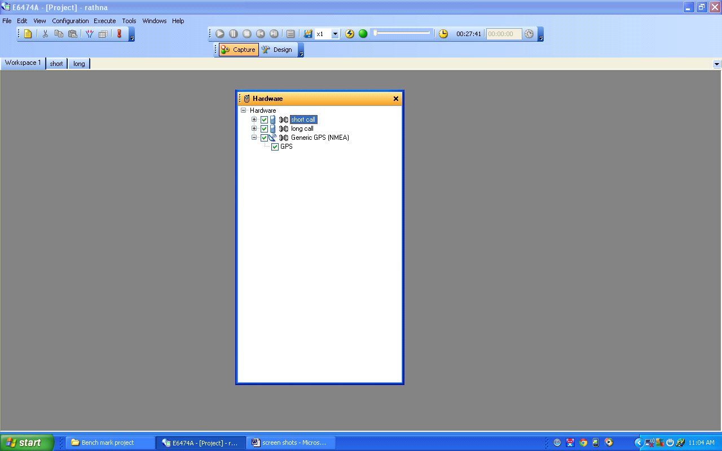

Fig. 7.1 Configuration of Hard ware Devices.

**7.3.2 Configuring The Calls**

In Sequencer window we specify the type of test to be done by the each device i.e. mobiles

**For Short Call:**

View System panel Sequencer (right click)Service model (right click)Parallel sequence Short call

**For Long Call:**

View System panel Sequencer (right click)Service model (right click)Parallel sequence Long call

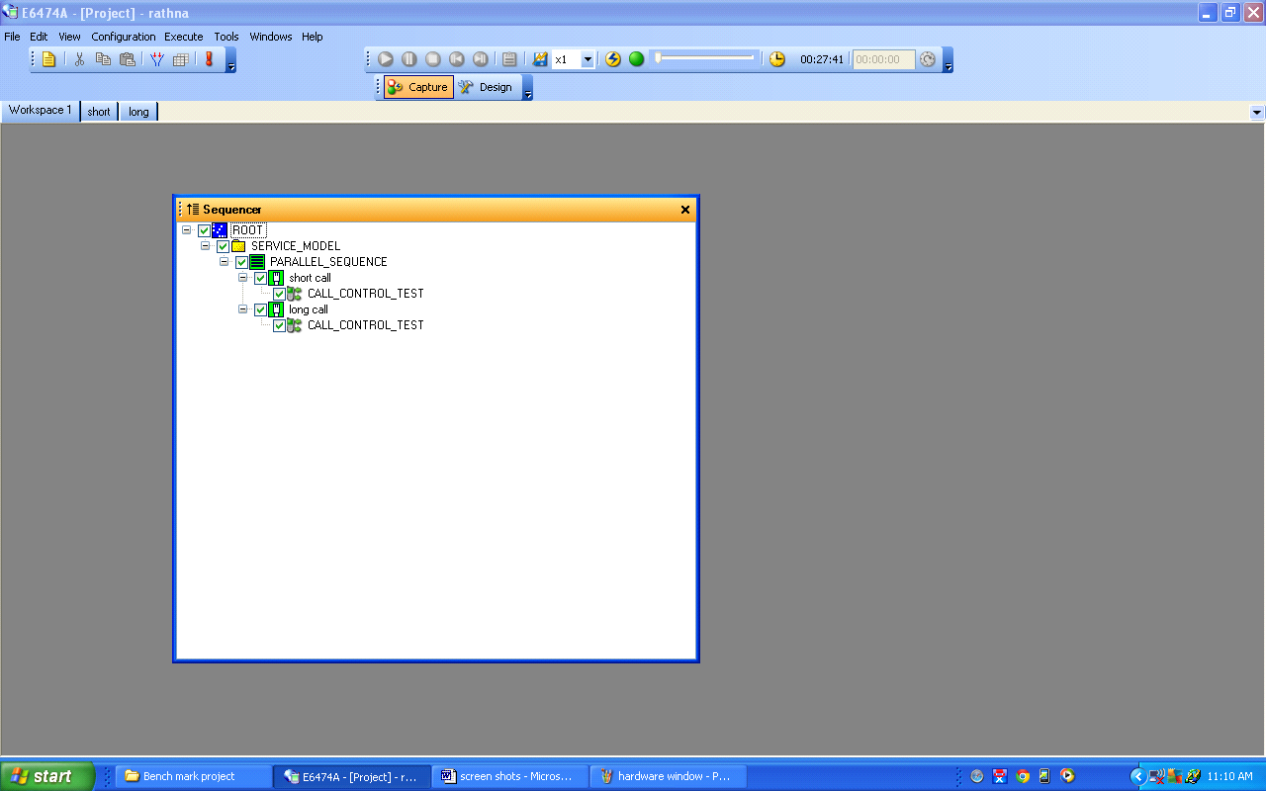

Fig 7.2 Configurations of Calls

**7.3.3 Configuring Short Call Properties**

Short Call CALL CONTROL TEST View Properties

* Number of times to run: Infinite

-The number of times for a call to run throughout the Drive Test if after a disruption.

* Inter Call Idle time: 5 sec

-Time duration between the calls

* Auto Dial:Yes

-Makes the call automatically after 5 sec (Inter Call Idle time)

* Call Statistics: Yes

**-**Display of No. of Dropped calls, Good calls etc., (Call Analysis)

* Immediate Dial: Yes

**-**To dial immediately after disconnection.

* Continuous Call: No

-Since the Short Call would be terminated and re-initiated throughout the Drive Test, it is configured asNo

* Call Duration: 40 sec

-Duration of the Short Call should be minimum to make a trail for every sector or cell

* Call Setup: 20 sec

-Time given to setup or answer a call, if it exceeds call will be terminated.

* Call number: Any number

-Destination or called party number

* Auto Answer: No

-If it is Yes, then the mobile would be only in incoming mode (doesn’t suit for Drive Test)

* COM Port: COM 58

-Number of port that to be connected to PC

* Voice MOS Test: No

-It is the Voice Mean Opinion score Test, not required for the Drive Test because person doing the Drive Test don’t speak throughout the Test.

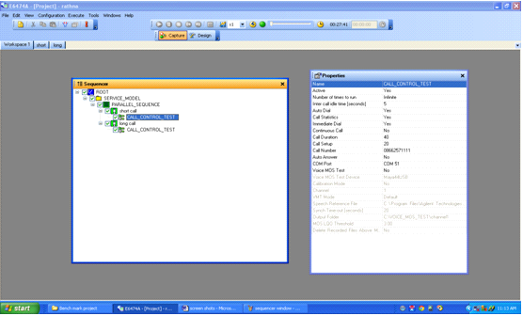

Fig 7.3 Configurations of Short Call Properties

**7.3.4 Configuring Long Calls Properties**

Long Call CALL CONTROL TEST View Properties

* Number of times to run: Infinite

-The number of times for a call to run throughout the Drive Test if after a disruption.

* Inter Call Idle time: 5 sec

-Time duration between the calls

* Auto Dial: Yes

-Makes the call automatically after 5 sec (Inter Call Idle time)

* Call Statistics: Yes

-Display of No. of Dropped calls, Good calls etc., (Call Analysis)

* Immediate Dial: Yes

-To dial immediately after disconnection.

* Continuous Call: Yes

-Since the Long Call would be operated throughout the Drive Test, it is configured as Yes

* Call Duration: NILL

-As the Long Call is operated throughout the Drive Test the Call duration need not be specified.

* Call Setup: 20 sec

-Time given to setup or answer a call, if it exceeds call will be terminated.

* Call number: Any number

-Destination or called party number

* Auto Answer: No

-If it is Yes, then the mobile would be only in incoming mode (doesn’t suit for Drive Test)

* COM Port: COM 57

-Number of port that to be connected to PC

* Voice MOS Test: No

-It is the Voice Mean Opinion score Test, not required for the Drive Test because person doing the Drive Test don’t speak throughout the Test.

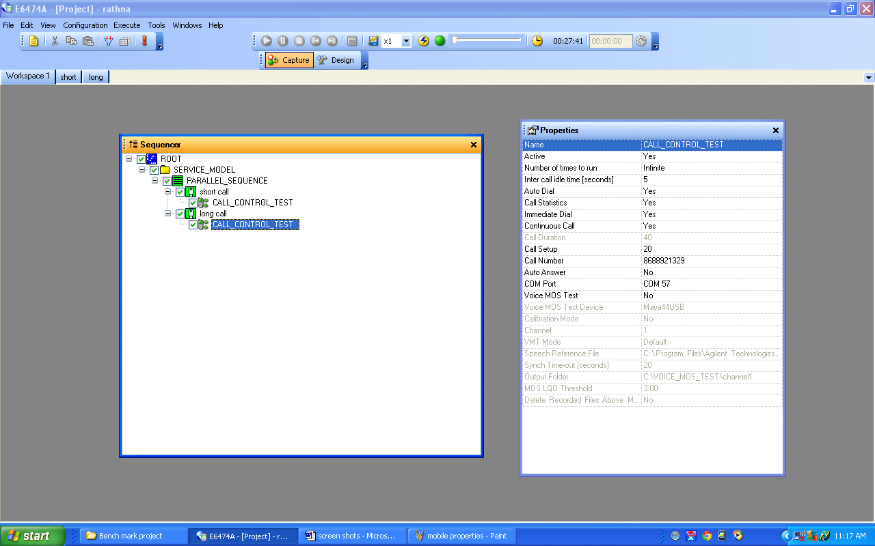

Fig 7.3 Configurations of Long Call Properties

**7.3.5 Configuring Of Map And Cell Site Data MAP:**

View Common Views Map Open map file (Load from Destination address in PC)

**Cell site Data:**

Tools Options Cell site Open cell site data file (Load from Destination address in PC)

Hyderabad map like streets, state highways, water bodies, national highways etc with cell sites given below

**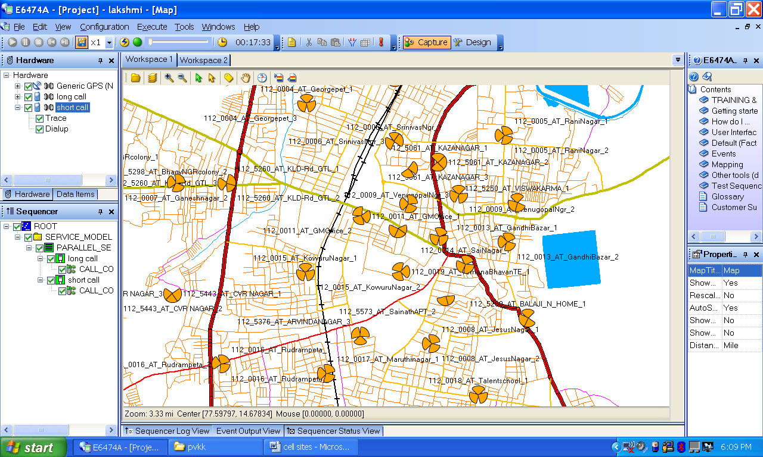**

Fig**:** Cell sites near Anantapuram are shown

**7.3.6 Configuring The Data Items**

Configuring the Data Items Selection of parameters like Rx level, Rx Quality, C\I ratio of both Short call and Long call which we want to display in the map through different colors and different ranges which are available in Data items window.

**For Short Call:**

View System Panel Data items Short Call Trace GSM signal -Rx Level

**For Long Call:**

View System Panel Data items Long Call Trace GSM signal

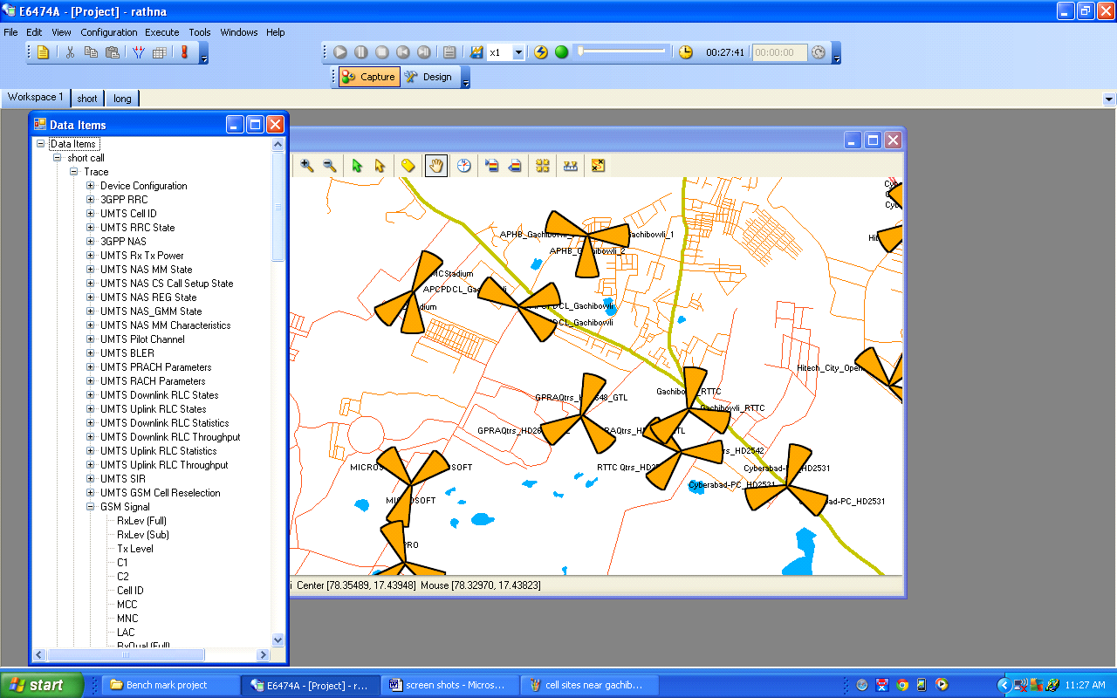

Fig. 7.3.6 Configurations of Data Items

**7.3.7 Map Legend**

**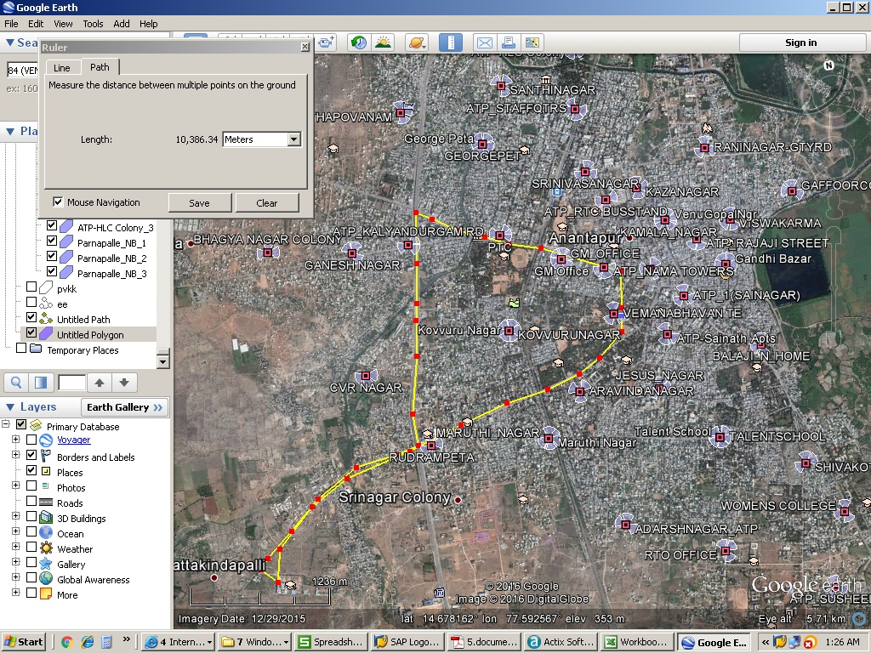**

**CHAPTER-8**

**DATA COLLECTION IN DRIVE TEST**

**8.1 OBSERVATIONS AND RECORDINGS**

Drive testing is the most common and maybe the best way to analyze Network performance by means of coverage evaluation, system availability, network capacity, network retain ability and call quality. Although it gives idea only on downlink side of the process, it provides huge perspective to the service provider about what’s happening with a subscriber point of view. The data, as per the requirements are observed and recorded. The data is analyzed for performance.

The following shots have been taken while conducting the drive test.

* **Drive test is nothing but collection of samples.**

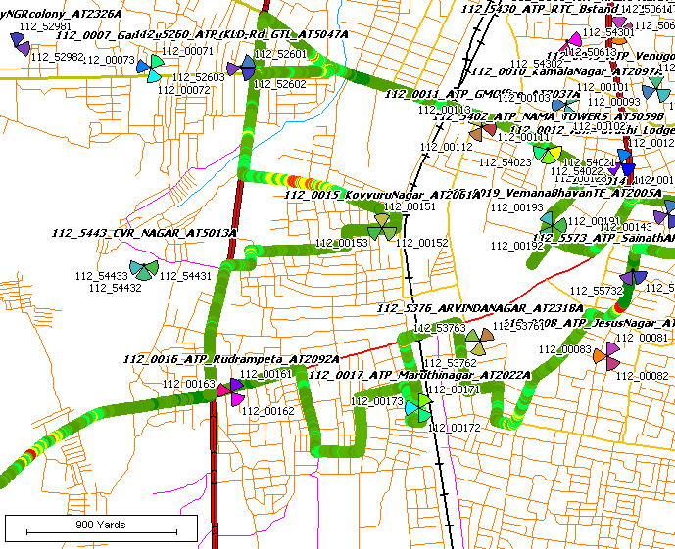

Fig. 8.1 Collection of samples of the Drive Test.

* GPS location or Vehicle position on the map is indicated with red pointer as shown below. Parameters like RSCP, Throughput and Ec/Io ratio of a call shown are below on the map.

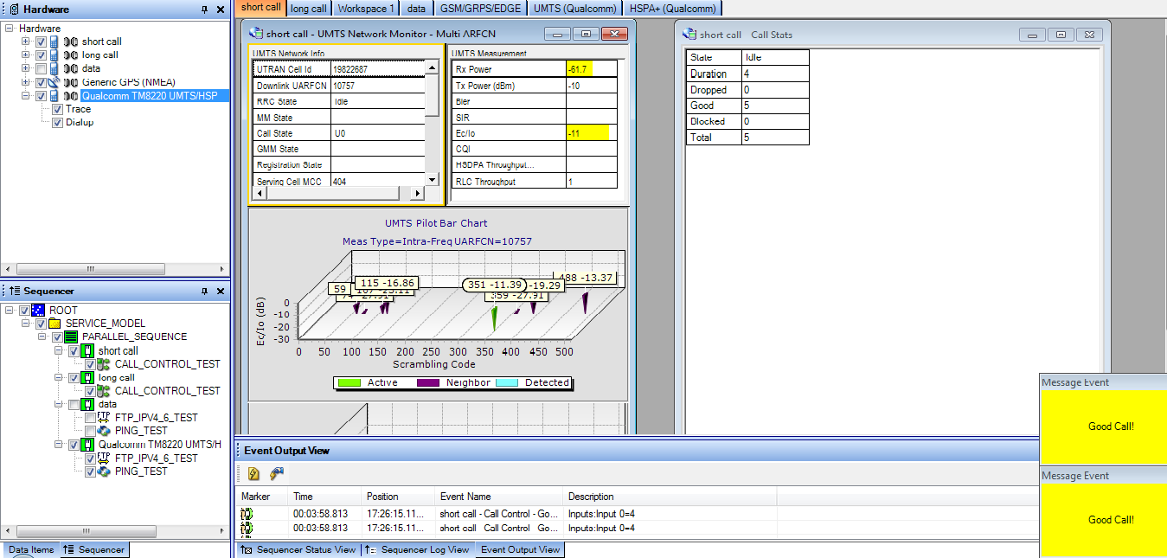

Fig. 8.2 BSNL Short Call & long call Views in Drive Test.

**8.2 DRIVE TEST ANALYSIS**

**8.2.1 Bench Marks Of TRAI**

Every leading network service provider in the market should follow the Benchmarks by the “TELECOM REGULATORY AUTHORITY OF INDIA”. A network is said to be good if it satisfies the benchmarks of TRAI.

**Downlink Parameters:**

• RSCP -85 to -95 dBm

• Ec/Io -3 to -8 dBm

• Handover success rate > 98%

• Call setup success rate > 98%

• Drop call rate < 3%

**Call Analysis:**

**(i) Call Setup Success Rate:**

**Rate of calls which are successfully established.**

CSSR= No. of calls successfully setup \* 100

Total no. of calls attempted

**(ii) Drop Call Rate:**

DCR= No. of Dropped calls \* 100

Total no. of calls Established

|  |  |  |  |
| --- | --- | --- | --- |
| **S.no** | **Parameter** | **BSNL** |  |
| 1 | No of Call attempts | 23 |
| 2 | Successfully Established | 22 |
| 3 | No. of Blocked calls | 1 |
| 4 | No. of Dropped Calls | 0 |

**(a) BSNL:**

(i) CSSR = 22 \* 100 = 95.65%

23

(iii) DCR = 1 \* 100 = 4.35%

23

**Coverage-Signal strength: -**

Computational Methodology

* Coverage-Signal strength 0 to -85dBm = (Number of Calls with signal strength between 0 to -85dBm/Total Calls made).
* Coverage-Signal strength 0 to -95dBm = (Number of Calls with signal strength between 0 to -95dBm/Total Calls made).

**Voice quality: -**

Computational Methodology

* %age samples with good voice quality= (Rx Qual samples with 0-5 value/Total Rx Qual Samples).

**Call setup success rate (CSSR): -**

Computational Methodology

* Call setup success rate (%age) = (Total Calls successfully established/Total number of call attempts).

**Blocked calls:-**

Computational Methodology

* %age Blocked calls = (100% - CSSR).

**Call Drop Rate: -**

Computational Methodology

* Call Drop Rate (%age) = (Total calls dropped after being established/ Total Calls successfully established).

**Handover Success Rate: -**

Computational Methodology

* Handover success rate (%age)=(1- (Total calls dropped during handover/ Total handover attempts))

**Carrier over Interference: -**

* C/I (%age) =(C/I samples with 15-30 value/Total C/I Samples).

**Advantages: -**

In competitive benchmarking, handover success rate, coverage and quality comparison like KPI of network is performed with competitors. Handover success rate, coverage and quality comparison for two operators for a city, results are taken using driving test tool, JDSU. It is also useful to network operators to know the problem in the network and the helps them to rectify them. In customer’s point of view, users get to know the best network operators

|  |  |  |  |  |  |  |  |  |  |  |  |  |  |  |  |  |  |  |
| --- | --- | --- | --- | --- | --- | --- | --- | --- | --- | --- | --- | --- | --- | --- | --- | --- | --- | --- |
| **File Summary Report**   |  |  |  |  |  |  |  |  |  | | --- | --- | --- | --- | --- | --- | --- | --- | --- | | This report shows a basic summary for the drive route. | | | | | | | | | | |  |  |  |  |  |  |  |  |  | |

|  |  |  |  |  |  |  |  |  |  |  |  |  |  |  |  |  |  |  |  |  |  |  |  |  |  |  |  |  |  |  |  |  |  |  |  |  |  |  |  |  |  |  |
| --- | --- | --- | --- | --- | --- | --- | --- | --- | --- | --- | --- | --- | --- | --- | --- | --- | --- | --- | --- | --- | --- | --- | --- | --- | --- | --- | --- | --- | --- | --- | --- | --- | --- | --- | --- | --- | --- | --- | --- | --- | --- | --- |
|  | | | | | | |  | | | | | | | | | | | | | | | | | | |  |  | |  | |  | |  | |  | | |  |  | |  | |
| **Logging Summary** | | | |
|
| Date | | | 09-Mar-16 | **Calls (MTC+MOC)** | |
|  | |
| Start Time | | | 15:34:01 | Attempts | 92 |
|  |  |
| Length | | | 2:02:41 | Setup Fail | 2 |
|  |  |
| Distance (km) | | | 10 | Setup OK | 90 |
|  |  |
| Speed (km/h) | | | 5 | Dropped | 3 |
|  |  |
| Cells Used | | | 41 | Completed | 76 |
|  |  |
| Fig: Call Analysis Summary | | | | | | | | | | | | | | | | | | | | | | | | | | | | | | | | |  | |  | | | 11 |  | |  | |
|  | |  | | |  |  | |  | |
|  | | |  |  |  |  |  |  |  |  |  |  |  |  |  | | --- | --- | --- | --- | --- | --- | --- | --- | --- | --- | --- | --- | --- | | Total Number of Calls | | | | 92 |  |  |  |  |  |  |  |  | |  |  |  |  |  |  |  |  | |  |  |  |  |  |  |  |  |  |  |  |  |  | |  |  |  |  |  |  |  |  |  |  |  |  |  | | Successful Incoming Calls | | | | 0 |  |  |  |  |  |  |  |  | |  |  |  |  |  |  |  |  | | Successful Outgoing Calls | | | | 90 |  |  |  |  |  |  |  |  | |  |  |  |  |  |  |  |  | | Total Successful Calls | | | | 90 |  |  | Connected 97.8% | | |  | 97.8% | | |  |  | |  |  |  |  |  |  |  |  |  |  |  |  |  | |  |  |  |  |  |  |  |  |  |  |  |  |  | | Call Failures – Incoming | | | | 0 |  |  |  |  |  |  |  |  | |  |  |  |  |  |  |  |  | | Call Failures – Outgoing | | | | 2 |  |  |  |  |  |  |  |  | |  |  |  |  |  |  |  |  | | Total Access Failures | | | | 2 |  |  | Access Failure Rate 2.2% | | |  | 2.2% | | |  |  | |  |  |  |  |  |  |  |  |  |  |  |  |  | |  |  |  |  |  |  |  |  |  |  |  |  |  | | Total Drops | | | | 3 |  |  | Drop Rate3.3% | |  |  | 3.3% | | |  |  |  |  | |  |  |  |  |  |  |  |  |  |  |  |  |  | | Total Completed calls | | | | 76 |  |  | Success Rate96.7% | |  |  | 96.7% | | |  |  |  |  | | | | | | | | | | | | | | | | | | | | | | | | | | |  | |  | |  | |  | |  |  | | |  | |  | |  |
|  |
|  | | | | | |  |
|  | | | | | |  | | | | | | | | | | | | | | | | | | |  |  | |  | |  | |  | |  | | |  |  | |  | |
| Table8.2: call summary | | | | | |  | | | | | | | | | | | | | | | | | | |  |  | |  | |  | |  | |  | | |  |  | |  | |
| **FIG** | | | | | |  |  | |  | |  | |  | |  | |
|  | | | | | |  |  | |  | |  | |  | |  | |
|  | | | | | |  |  | |  | |  | |  | |  | |
|  | | | | | |  |  | |  | |  | |  | |  | |
|  | | | | | |  |  | |  | |  | |  | |  | |
|  | | | | | |  |  | |  | |  | |  | |  | |
|  | | | | | |  |  | |  | |  | |  | |  | |
|  | | | | | |  |  | |  | |  | |  | |  | |
|  | | | | | |  |  | |  | |  | |  | |  | |
| Fig8.2: Quality Of Calls Analysis | | | | | |  |  | |  | |  | |  | |  | |  | |  | |
|  | | | | | |  |  | |  | |  | |  | |  | |  | |  | |
|  | | | | | |  |  | |  | |  | |  | |  | |
|  | | | | | |  |  | |  | |  | |  | |  | |
|  | | | | | |  |  | |  | |  | |  | |  | |
|  | | | | | |  |  | |  | |  | |  | |  | |
|  | | | | | |  |  | |  | |  | |  | |  | |
|  | | | | | |  |  | |  | |  | |  | |  | |
|  | | | | | |  |  | |  | |  | |  | |  | |
|  | | | | | |  |  | |  | |  | |  | |  | |
|  | | | | | |  |  | |  | |  | |  | |  | |
|  | | | | | |  |  | |  | |  | |  | |  | |
|  | | | | | |  |  | |  | |  | |  | |  | |
|  | | | | | |  |  | |  | |  | |  | |  | |
|  | | | | | |  |  | |  | |  | |  | |  | |
|  | | | | | |  | | | | | | | | | | | | | | | | | | |  |  | |  | |  | |  | |
|  | | | | | |  | | | | | | | | | | | | | | | | | | |  |  | |  | |  | |  | |
| |  | | --- | |  | | | | | | |  | | | | | | | | | | | | | | | | | | |  |  | |  | |  | |  | |  | | |  |  | |  | |
|  | | | | | |  | | | | | | | | | | | | | | | | | | |  |  | |  | |  | |  | |  | | |  |  | |  | |
|  | | | | | |  | | | | | | | | | | | | | | | | | | |  |  | |  | |  | |  | |  | | |  |  | |  | |
|  | | | | | |  | | | | | | | | | | | | | | | | | | |  |  | |  | |  | |  | |  | | |  |  | |  | |
|  | | | | | |  | | | | | | | | | | | | | | | | | | |  |  | |  | |  | |  | |  | | |  |  | |  | |
|  | | | | | |  | | | | | | | | | | | | | | | | | | |  |  | |  | |  | |  | |  | | |  |  | |  | |
|  | | | | | |  | | | | | | | | | | | | | | | | | | |  |  | |  | |  | |  | |  | | |  |  | |  | |
|  | | | | | |  | | | | | | | | | | | | | | | | | | |  |  | |  | |  | |  | |  | | |  |  | |  | |
| **CHAPTER-9**  **POST PROCESSING**  **9.1 INTRODUCTION TO ACTIX**  Actix analyzer is a software application running on Microsoft Windows that provides a series of analysis tools for post processing cellular network data.  The tool is designed to address the applications such as:   * Network performance and optimization * Feature testing * Service validation * Problem diagnosis and analysis * Network Benchmarking   A post-processing tool for GSM, GPRS, UMTS, CDMA-one, CDMA2000 andIS-95. Actix provides users the ability to manage, visualize, replay, analyze and optimize networks based on collected data.  A-RVS (Rollout Verification Solution)  Module will be used to trouble shoot and optimize UMTS networks.  ACTIX, as a network optimization platform, is a powerful tool that will allow you to discover, locate, manage, troubleshoot and find solutions to network problem.    Fig 9.1: signal quality  Handover during call:    Fig9.1 : Call drop  **CHAPTER-10**  **RESULTS**  Case 1:  we are using an drive test tool JDSU V16.3 to gather the inputs of BSNL network.  Case 2:  By using this tool now we are going to collect various inputs to ACTIX post processing tool generate GSM RF outputs to our surroundings.  Case 3:  After collecting the data from drive test tool these inputs can be given to ACTIX post processing tool  Case 4:  By using this tool generate GSM RF outputs of BSNL service provider service quality, coverage capacity and speed of the network and understand the quality of service parameters.  **The generated outputs from ACTIX tool are shown below**  C:\Users\Manohar\AppData\Local\Microsoft\Windows\INetCache\Content.Word\svit_2G_call_ok.jpg  **Fig10.1: during call setup**  C:\Users\Manohar\AppData\Local\Microsoft\Windows\INetCache\Content.Word\svit_2G_Handover success_failure.jpg  **Fig10.2: During hand over process**  C:\Users\Manohar\AppData\Local\Microsoft\Windows\INetCache\Content.Word\svit_2G_rxlevel.jpg  **Fig10.3: Receiver level**  C:\Users\Manohar\AppData\Local\Microsoft\Windows\INetCache\Content.Word\svit_2g_rxquality.jpg  **Fig10.4: Receiver quality**  Case 5:  The above generated GSM RF outputs can be used to understand the quality of service parameters of any particular network.  Case 6:  Based on this generated outputs we can improve QOS of a particular network  **CHAPTER-11**  **CONCLUSION & FUTURE SCOPE**  In this project we have seen the Architecture of 3G Network and its element functions.And also studied the working principle of WCDMA Air interface . we have seen the different tasks conducted during the optimization activity of the studied BSNL 3G network in Ananantapur.All problems we have detected through Agilent E6474A-X Drive Test tool and Actix post processing tool.It is difficult to monitor and maintain the 3G network without thses tools.  The Indian telecommunication industry is the second largest telecommunication network in the world. The main drivers in this extraordinary growth are because of government’s telecom reforms and the stupendous success of 3G standard. In this environment, high quality of service is a competitive advantage for a service provider. Service providers must continually strive to improve their quality of service if they want to keep customers. If too much time is spent simply reacting to customer complaints, there may not be enough time to improve overall service quality. Hence RF optimization is a very important process in any service provider’s operating lifecycle.  Optimization is a very critical set of activities in the lifecycle of any wireless network. The primary tool used by most service providers to solve network problems is a Drive-test tool system, with the goal of collecting measurement data as a function of location. Once the data has been collected, engineers can use the collection and post-processing can be solved effectively and efficiently.  In the project, RF performance parameters such as the received signal strength, Ec/Io, throughput, channel quality indicator (CQI), pilot pollution etc., Also we will measure short-call and long-call control tests from the drive testing process. And this project requires us to work on various tools such as JDSU16.3 Drive test tools, ACTIX post processing tool.The overall objectives of any RF design depend on number of factors that are determined by needs of customer. Through radio network optimization the service quality and resources usage of the network are greatly improved and the balance among coverage capacity and quality is achieved and been performed in BSNL service area.  **REFERENCES**  Websites:-   * [http://www.sss-mag.com](http://www.sss-mag.com/) * [www.electronicdesign.com](http://www.electronicdesign.com/) * [www.3g-generation.com](http://www.3g-generation.com/) * [www.3gtoday.com](http://www.3gtoday.com/) * [http://www.pctechguide.com](http://www.pctechguide.com/)     **APPENDIX-A** | | | | | |  | | | | | | | | | | | | | | | | | | |  |  | |  | |  | |  | |  | | |  |  | |  | |
|  | | | | | |  | | | | | | | | | | | | | | | | | | |  |  | |  | |  | |  | |  | | |  |  | |  | |
| Cell site parameters for import CDMA   |  |  |  |  |  | | --- | --- | --- | --- | --- | |  | **Imported** | **Analyzer** | **Analyzer Name** | **Purpose** | |  | **Parameter** | **Group** |  |  | |  |  |  |  |  | |  | Site Name | CDMA\_Site | SiteName | Text description of the Site for | |  |  |  |  | display on map. | |  | Site Number | CDMA\_Site | SiteID | Numeric identifier for the Site. | |  | Latitude | CDMA\_Site | SiteLatitude | Locates Site icons on the map. | |  | Longitude | CDMA\_Site | SiteLongitude | Locates Site icons on the map. | |  | Sector | CDMA\_Cell | Sector ID | Sector-specific information useful | |  | Number |  | Can be 1,2,3 etc. | for display on maps. | |  |  |  | or a combination |  | |  |  |  | of site numbers |  | |  | Azimuth | CDMA\_Cell | Azimuth | Orients the sector icons on the | |  |  |  |  | map. | |  | Beamwidth | CDMA\_Cell | Beamwidth | Governs the shape of the sector | |  |  |  |  | 'wedge' on the map to reflect the | |  |  |  |  | beamwidth of the antenna | |  |  |  |  | deployed at the site. | |  | PN Offset | CDMA\_Cell | PN | Used in CDMA Toolkit calculations, | |  |  |  |  | lines to neighbor cells and to color | |  |  |  |  | sectors/sites on maps to reflect PN | |  |  |  |  | planning. | |  | Base Station | CDMA\_Cell | EIRP | Base station power, used in CDMA | |  | Power\* |  |  | Toolkit calculations. | |  | Mobile | CDMA\_Cell | MCC | Mobile Country Code. For | |  | Country |  |  | information only. | |  | Code\* |  |  |  | |  | System | CDMA\_Cell | SID | For information only. | |  | Identity\* |  |  |  | |  | Network | CDMA\_Cell | NID | For information only. | |  | Identity\* |  |  |  | |  | Broadcast | CDMA\_Cell | BID | For information only. | |  | Identity\* |  |  |  | |  | PctPilot\* | CDMA\_Cell | PctPilot | For information only. | |  | PctTraffic\* | CDMA\_Cell | PctTraffic | For information only. | |  | PctPaging\* | CDMA\_Cell | PctPaging | For information only. | |  | PctSync\* | CDMA\_Cell | PctSync | For information only. | |  | Active Set | CDMA\_Cell | SRCH\_WIN\_A | Used in Analyzer‘s CDMA Toolkit | |  | Search |  |  | calculations to compare current | |  | Window |  |  | search window settings with those | |  | Setting\* |  |  | suggested by Analyzer. | | | | | | | | |  | |  | |  | |  | |  | |  | |  | |  |  |
|  | | | | | |  | | | | | | | | | | | | | | | | | | |  |  | |  | |  | |  | |  | | |  |  | |  | |
|  | | | | | |  | | | | | | | | | | | | | | | | | | |  |  | |  | |  | |  | |  | | |  |  | |  | |
|  | | | | | |  | | | | | | | | | | | | | | | | | | |  |  | |  | |  | |  | |  | | |  |  | |  | |
|  | | | | | |  | | | | | | | | | | | | | | | | | | |  |  | |  | |  | |  | |  | | |  |  | |  | |
|  | | | | | |  | | | | | | | | | | | | | | | | | | |  |  | |  | |  | |  | |  | | |  |  | |  | |
|  | | | | | |  | | | | | | | | | | | | | | | | | | |  |  | |  | |  | |  | |  | | |  |  | |  | |
|  | | | | | |  | | | | | | | | | | | | | | | | | | |  |  | |  | |  | |  | |  | | |  |  | |  | |
|  | | | | | |  | | | | | | | | | | | | | | | | | | |  |  | |  | |  | |  | |  | | |  |  | |  | |
|  | | | | | |  | | | | | | | | | | | | | | | | | | |  |  | |  | |  | |  | |  | | |  |  | |  | |
|  | | | | | |  | | | | | | | | | | | | | | | | | | |  |  | |  | |  | |  | |  | | |  |  | |  | |
|  | | | | | |  | | | | | | | | | | | | | | | | | | |  |  | |  | |  | |  | |  | | |  |  | |  | |
|  | | | | | |  | | | | | | | | | | | | | | | | | | |  |  | |  | |  | |  | |  | | |  |  | |  | |
|  | | | | | |  | | | | | | | | | | | | | | | | | | |  |  | |  | |  | |  | |  | | |  |  | |  | |
|  | | | | | |  | | | | | | | | | | | | | | | | | | |  |  | |  | |  | |  | |  | | |  |  | |  | |
|  | | | | | |  | | | | | | | | | | | | | | | | | | |  |  | |  | |  | |  | |  | | |  |  | |  | |
|  | | | | | |  | | | | | | | | | | | | | | | | | | |  |  | |  | |  | |  | |  | | |  |  | |  | |
|  | | | | | |  | | | | | | | | | | | | | | | | | | |  |  | |  | |  | |  | |  | | |  |  | |  | |
|  | | | | | |  | | | | | | | | | | | | | | | | | | |  |  | |  | |  | |  | |  | | |  |  | |  | |
|  | | | | | |  | | | | | | | | | | | | | | | | | | |  |  | |  | |  | |  | |  | | |  |  | |  | |
|  | | | | | |  | | | | | | | | | | | | | | | | | | |  |  | |  | |  | |  | |  | | |  |  | |  | |
|  | | | | | |  | | | | | | | | | | | | | | | | | | |  |  | |  | |  | |  | |  | | |  |  | |  | |
|  | | | | | |  | | | | | | | | | | | | | | | | | | |  |  | |  | |  | |  | |  | | |  |  | |  | |
|  | | | | | |  | | | | | | | | | | | | | | | | | | |  |  | |  | |  | |  | |  | | |  |  | |  | |
|  | | | | | |  | | | | | | | | | | | | | | | | | | |  |  | |  | |  | |  | |  | | |  |  | |  | |
|  | | | | | |  | | | | | | | | | | | | | | | | | | |  |  | |  | |  | |  | |  | | |  |  | |  | |
|  | | | | | |  | | | | | | | | | | | | | | | | | | |  |  | |  | |  | |  | |  | | |  |  | |  | |
|  | | | | | |  | | | | | | | | | | | | | | | | | | |  |  | |  | |  | |  | |  | | |  |  | |  | |
|  | | | | | |  | | | | | | | | | | | | | | | | | | |  |  | |  | |  | |  | |  | | |  |  | |  | |
|  | | | | | |  | | | | | | | | | | | | | | | | | | |  |  | |  | |  | |  | |  | | |  |  | |  | |

|  |  |  |  |  |  |  |  |  |  |  |  |  |  |  |  |  |  |  |  |  |  |  |  |  |  |  |  |  |  |  |  |  |  |  |  |  |  |  |  |  |  |  |  |  |  |  |
| --- | --- | --- | --- | --- | --- | --- | --- | --- | --- | --- | --- | --- | --- | --- | --- | --- | --- | --- | --- | --- | --- | --- | --- | --- | --- | --- | --- | --- | --- | --- | --- | --- | --- | --- | --- | --- | --- | --- | --- | --- | --- | --- | --- | --- | --- | --- |
|  | | | | | | | | | | | | | | | | | | | | |  | |  | |  | |  | | | | | | | | | |  | |  | | |  |  |  | |  |
|  | | | | | | | | | | | | | | | | | | | | |  | |  | |  | |  | | | | | | | | | |  | |  | | |  |  |  | |  |
|  | | | | | | | | | | | | | | | | | | | | |  | |  | |  | |  | | | | | | | | | |  | |  | | |  |  |  | |  |
|  | | | | | | | | | | | | | | | | | | | | |  | |  | |  | |  | | | | | | | | | |  | |  | | |  |  |  | |  |
|  | | | | | | | | | | | | | | | | | | | | |  | |  | |  | |  | | | | | | | | | |  | |  | | |  |  |  | |  |
|  | | | | | | | | | | | | | | | | | | | | |  | |  | |  | |  | | | | | | | | | |  | |  | | |  |  |  | |  |
|  | | | | | | | | | | | | | | | | | | | | |  | |  | |  | |  | | | | | | | | | |  | |  | | |  |  |  | |  |
|  | | | | | | | | | | | | | | | | | | | | |  | |  | |  | |  | | | | | | | | | |  | |  | | |  |  |  | |  |
|  | | | | | | | | | | | | | | | | | | | | |  | |  | |  | |  | | | | | | | | | |  | |  | | |  |  |  | |  |
|  | | | | | | | | | | | | | | | | | | | | |  | |  | |  | |  | | | | | | | | | |  | |  | | |  |  |  | |  |
|  | | | | | | | | | | | | | | | | | | | | |  | |  | |  | |  | | | | | | | | | |  | |  | | |  |  |  | |  |
|  | | | | | | | | | | | | | | | | | | | | |  | |  | |  | |  | | | | | | | | | |  | |  | | |  |  |  | |  |
|  | | | | | | | | | | | | | | | | | | | | |  | |  | |  | |  | | | | | | | | | |  | |  | | |  |  |  | |  |
|  | |  |  |  | | | | | | | |  | | | |  | | |  | | |  | |  | | | | |  | |
|  |  | |  | | | | | | | |  | | |  | | |  | |  | | |  | | | |  | | |
|  | | | | | | | | | | | | | | | | | | | | | **-** | | | | | | | | | | | | | | |  | | | |
|  | | | | | | | | | | | | | | | | | | | | |  | |  | |  | |  | | | | | | | | | |  | |  | | |  |  |  | |  |
| |  | | --- | |  | | | | | | | | | | | | | | | | | | | | | |  | |  | |  | |  | | | | | | | | | |  | |  | | |  |  |  | |  |
|  | | | | | | | | | | | | | | | | | | | | |  | |  | |  | |  | | | | | | | | | |  | |  | | |  |  |  | |  |
|  | | | | | | | | | | | | | | | | | | | | |  | |  | |  | |  | | | | | | | | | |  | |  | | |  |  |  | |  |
|  | | | | | | | | | | | | | | | | | | | | |  | |  | |  | |  | | | | | | | | | |  | |  | | |  |  |  | |  |
|  | | | | | | | | | | | | | | | | | | | | |  | |  | |  | |  | | | | | | | | | |  | |  | | |  |  |  | |  |
|  | | | | | | | | | | | | | | | | | | | | |  | |  | |  | |  | | | | | | | | | |  | |  | | |  |  |  | |  |
|  | | | | | | | | | | | | | | | | | | | | |  | |  | |  | |  | | | | | | | | | |  | |  | | |  |  |  | |  |
|  | | | | | | | | | | | | | | | | | | | | |  | |  | |  | |  | | | | | | | | | |  | |  | | |  |  |  | |  |
|  | | | | | | | | | | | | | | | | | | | | |  | |  | |  | |  | | | | | | | | | |  | |  | | |  |  |  | |  |
|  | | | | | | | | | | | | | | | | | | | | |  | |  | |  | |  | | | | | | | | | |  | |  | | |  |  |  | |  |
|  | | | | | | | | | | | | | | | | | | | | |  | |  | |  | |  | | | | | | | | | |  | |  | | |  |  |  | |  |
|  | | | | | | | | | | | | | | | | | | | | |  | |  | |  | |  | | | | | | | | | |  | |  | | |  |  |  | |  |
|  | | | | | | | | | | | | | | | | | | | | |  | |  | |  | |  | | | | | | | | | |  | |  | | |  |  |  | |  |
|  | | | | | | | | | | | | | | | | | | | | |  | |  | |  | |  | | | | | | | | | |  | |  | | |  |  |  | |  |
|  | | | | | | | | | | | | | | | | | | | | |  | |  | |  | |  | | | | | | | | | |  | |  | | |  |  |  | |  |
|  | | | | | | | | | | | | | | | | | | | | |  | |  | |  | |  | | | | | | | | | |  | |  | | |  |  |  | |  |
|  | | | | | | | | | | | | | | | | | | | | |  | |  | |  | |  | | | | | | | | | |  | |  | | |  |  |  | |  |
|  | | | | |  | |  | |  | | | |  | | | | |  | | | | | | | | | |
|  | | | | |  | |  | |  | | | |  | | | | |  | | | | | | | | | |
|  | | | | | | | | | | | | | | | | | | | | | | | | | | | | | |  | | |  | |  | | |  | | |  | | | |  | | |  |
|  | | |  | |  | | |  | | |  | | | |  | | |  |
|  | | | | | |  | |  | |  | | | | |  | | | | |  | | | | | | | | | |  | | |  | |  | | |  | | |  | | | |  | | |  |
|  | | | | |  | |  | |  | | | |  | | | | |
|  | | | | |  | |  | |  | | | |  | | | | |
|  | | | | |  | |  | |  | | | |
|  | | | | | |  | |  | |  | | | | |  | | | | |  | | | | | | | | | |  | | |  | |  | | |  | | |  | | | |  | | |  |
|  | | | | |  | |  | |  | | | |  | | | | |  | | | | | | | | | |  | | | |  | |
|  | | | | |  | |  | |  | | | |  | | | | |  | | | | | | | | | |
|  | | | | |  | |  | |  | | | |  | | | | |  | | | | | | | | | |  | | | |  | |
|  | | | | | |  | |  | |  | | | | |  | | | | |  | | | | | | | | | |  | | |  | |  | | |  | | |  | | | |  | | |  |
|  | | | | |  | |  | |  | | | |  | | | | |  | | | | | | | | | |  | | | |
|  | | | | |  | |  | |  | | | |  | | | | |  | | | | | | | | | |
|  | | | | |  | |  | |  | | | |  | | | | |  | | | | | | | | | |  | | | |
|  | | | | |  | |  | |  | | | |  | | | | |  | | | | | | | | | |  | | | |
|  | | | | |  | |  | |  | | | |  | | | | |  | | | | | | | | | |  | | | |
|  | | | | |  | |  | |  | | | |  | | | | |  | | | | | | | | | |  | | | |
|  | | | | |  | |  | |  | | | |  | | | | |  | | | | | | | | | |  | | | |
|  | | | | |  | |  | |  | | | |  | | | | |  | | | | | | | | | |  | | | |
|  | | | | |  | |  | |  | | | |  | | | | |  | | | | | | | | | |  | | | |
|  | | | | |  | |  | |  | | | |  | | | | |  | | | | | | | | | |  | | | |
|  | | | | |  | |  | |  | | | |  | | | | |  | | | | | | | | | |  | | | |
|  | | | | | |  | |  | |  | | | | |  | | | | |  | | | | | | | | | |  | | |  | |  | | |  | | |  | | | |  | | |  |
|  | | | | | |  | |  | |  | | | | |  | | | | |  | | | | | | | | | |  | | |  | |  | | |  | | |  | | | |  | | |  |
|  | | | | | |  | |  | |  | | | | |  | | | | |  | | | | | | | | | |  | | |  | |  | | |  | | |  | | | |  | | |  |
| |  | | --- | |  | | | | | | |  | |  | |  | | | | |  | | | | |  | | | | | | | | | |  | | |  | |  | | |  | | |  | | | |  | | |  |
|  | | | | | |  | |  | |  | | | | |  | | | | |  | | | | | | | | | |  | | |  | |  | | |  | | |  | | | |  | | |  |
|  | | | | | |  | |  | |  | | | | |  | | | | |  | | | | | | | | | |  | | |  | |  | | |  | | |  | | | |  | | |  |
|  | | | | | |  | |  | |  | | | | |  | | | | |  | | | | | | | | | |  | | |  | |  | | |  | | |  | | | |  | | |  |
|  | | | | | |  | |  | |  | | | | |  | | | | |  | | | | | | | | | |  | | |  | |  | | |  | | |  | | | |  | | |  |
|  | | | | | |  | |  | |  | | | | |  | | | | |  | | | | | | | | | |  | | |  | |  | | |  | | |  | | | |  | | |  |
|  | | | | | |  | |  | |  | | | | |  | | | | |  | | | | | | | | | |  | | |  | |  | | |  | | |  | | | |  | | |  |
|  | | | | | |  | |  | |  | | | | |  | | | | |  | | | | | | | | | |  | | |  | |  | | |  | | |  | | | |  | | |  |
|  | | | | | |  | |  | |  | | | | |  | | | | |  | | | | | | | | | |  | | |  | |  | | |  | | |  | | | |  | | |  |
|  | | | | | |  | |  | |  | | | | |  | | | | |  | | | | | | | | | |  | | |  | |  | | |  | | |  | | | |  | | |  |
|  | | | | | |  | |  | |  | | | | |  | | | | |  | | | | | | | | | |  | | |  | |  | | |  | | |  | | | |  | | |  |
|  | | | | | |  | |  | |  | | | | |  | | | | |  | | | | | | | | | |  | | |  | |  | | |  | | |  | | | |  | | |  |
|  | | | | | |  | |  | |  | | | | |  | | | | |  | | | | | | | | | |  | | |  | |  | | |  | | |  | | | |  | | |  |
|  | | | | | |  | |  | |  | | | | |  | | | | |  | | | | | | | | | |  | | |  | |  | | |  | | |  | | | |  | | |  |
|  | | | | | |  | |  | |  | | | | |  | | | | |  | | | | | | | | | |  | | |  | |  | | |  | | |  | | | |  | | |  |
|  | | | | | |  | |  | |  | | | | |  | | | | |  | | | | | | | | | |  | | |  | |  | | |  | | |  | | | |  | | |  |
|  | | | | | |  | |  | |  | | | | |  | | | | |  | | | | | | | | | |  | | |  | |  | | |  | | |  | | | |  | | |  |
|  | | | | | |  | |  | |  | | | | |  | | | | |  | | | | | | | | | |  | | |  | |  | | |  | | |  | | | |  | | |  |
|  | | | | | |  | |  | |  | | | | |  | | | | |  | | | | | | | | | |  | | |  | |  | | |  | | |  | | | |  | | |  |
|  | | | | | |  | |  | |  | | | | |  | | | | |  | | | | | | | | | |  | | |  | |  | | |  | | |  | | | |  | | |  |
|  | | | | | |  | |  | |  | | | | |  | | | | |  | | | | | | | | | |  | | |  | |  | | |  | | |  | | | |  | | |  |
|  | | | | | |  | |  | |  | | | | |  | | | | |  | | | | | | | | | |  | | |  | |  | | |  | | |  | | | |  | | |  |